****word

**

**PharmaPlus Web Application**

**Graduation Project**

*Empowering Pharmacies, Improving Patient Care*

**Team Names:**

* 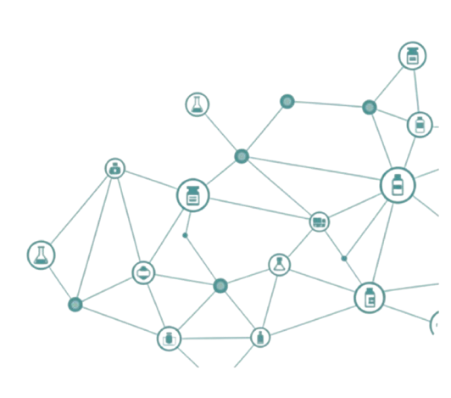*Amr Tamer*
* *Mazen Ahmed*
* *Mariam Mohamed*
* *Noha Shehab*

**Under The Supervision of:**

*Eng. Ashraf Sadek*

**

**Contents**

1

**Introduction & Project Overview** 4

Problem Statement 4

Description 5

Objectives 7

**Requirements Analysis** 9

**Analysis Models** 12

Use Case Diagram 12

System Architecture Diagram 13

**Design Phase** 14

ERD Diagram (Database Design) 14

Database Schema 15

Component Diagram 19

UI/UX Design 20

**Implementation Phase** 30

Technologies & Tools Used 30

System Modules 31

Folder Structure 33

Code Samples 34

API Documentation 38

**Overview** 38

**Users Endpoints (/api/users)** 38

**Medicines Endpoints (/api/medicines)** 39

**Pharmacies Endpoints (/api/pharmacies)** 40

**Orders Endpoints (/api/orders)** 40

**Request & Response Examples** 41

**Testing Phase** 48

**Student Wok** 53

Mazen Ahmed 53

Noha Shehab 57

Amr Tamer 60

Mariam Mohamed 64

**Conclusion & Future Work** 73

Conclusion 73

Future Work 73

## **Introduction & Project Overview**

## Problem Statement

Many pharmacies still rely on **manual and disconnected systems**, making it difficult for customers **to find medicines**, **compare prices**, and **manage prescriptions efficiently**.

Customers also struggle to locate the nearest pharmacy that has the required medicine available, leading to wasted time, repeated visits, and poor overall customer experience.

Additionally, pharmacy administrators struggle with **inventory management**, **order processing**, and **lack real-time business insights**.

PharmaPlus solves these challenges by providing a multi-pharmacy platform that empowers customers to locate nearby pharmacies through interactive mapping, enables administrators to manage operations efficiently with real-time analytics, and supports scalable multi-pharmacy network management.

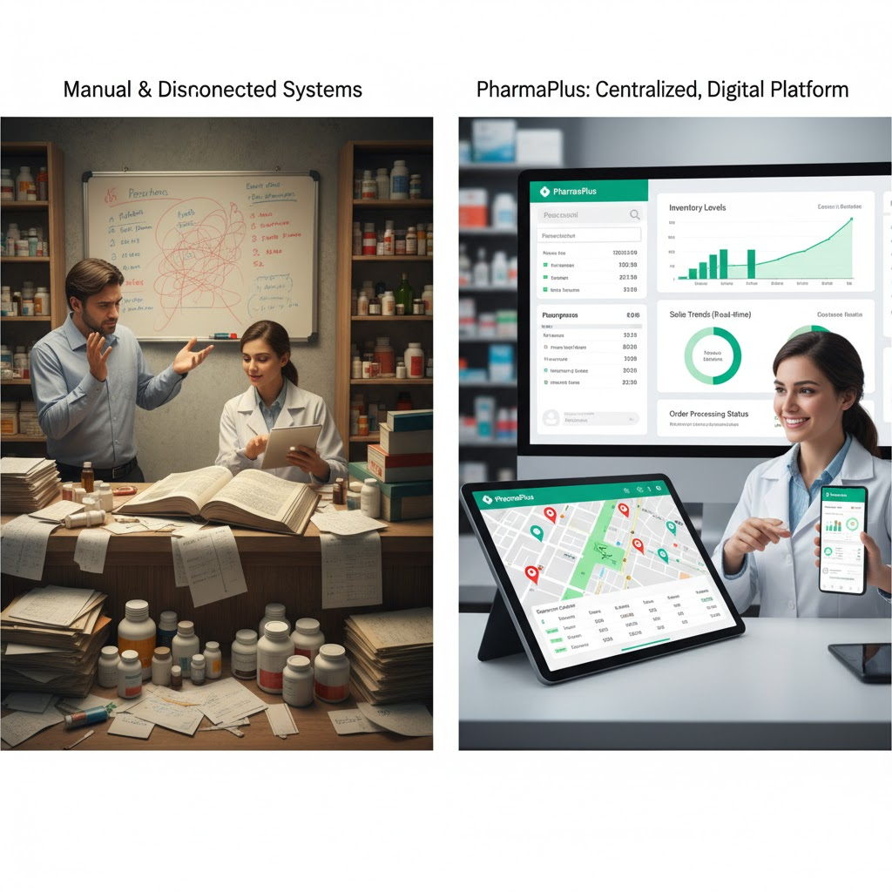

## Description

PharmaPlus is a full-stack, web-based pharmaceutical management and e-commerce platform designed to digitize and streamline pharmacy operations.

**Core Functionality**

The platform provides three distinct user personas with tailored dashboards and capabilities:

1. **Customers**: Browse and purchase medications, upload prescriptions, track orders, manage shopping carts, and communicate with pharmacy staff
2. **Pharmacy Administrators**: Manage medicine inventory, monitor orders, track revenue, analyze stock levels, and handle customer interactions
3. **Super-Administrators**: Oversee multiple pharmacies, access global analytics, generate comprehensive reports, manage pharmacy networks, and monitor system-wide performance

**Key Features**

* **E-Commerce Platform**: Product search, filtering, shopping cart management, and secure checkout
* **Authentication & Authorization**: Multi-role JWT-based authentication with role-based access control
* **Admin Dashboards**: Real-time metrics, sales trends, inventory tracking, and order management
* **Prescription Management**: User-friendly prescription upload and validation system
* **Chat Interface**: Built-in communication between customers and pharmacy staff
* **Advanced Analytics**: Multi-pharmacy performance tracking, sales trends, stock movements, and order status visualization
* **Responsive UI**: Mobile-friendly design with smooth animations and intuitive navigation

## Objectives

Primary Objectives (Main Goals)

1. **Digitalize Pharmacy Operations**  
   Replace paperwork with an automated system to reduce mistakes and make daily tasks easier.
2. **Improve Customer Experience**  
   Help customers quickly find medicines, buy them easily, manage prescriptions, chat with pharmacy staff, and order from the closest pharmacy using an interactive map.
3. **Support Administrators**  
   Provide real-time data, useful insights, inventory tracking, and fast order management to help managers make better decisions.
4. **Create a Multi-Pharmacy Network**  
   Allow control of many pharmacies from one system, offer system-wide analytics, and support location-based ordering using geolocation.

Secondary Objectives (Additional Goals)

1. **Ensure Security & Compliance**Use role-based access (different permissions for different users), keep logs of actions, follow rules and regulations, and protect all sensitive data.
2. **Maintain Technical Quality**  
   Use a modern tech stack (React 19, Vite), add location maps (Leaflet), keep the code organized, ensure the system works on all screens, and keep it stable.
3. **Support Business Growth**  
   Increase sales, reach more customers, reduce operating costs, create more revenue opportunities across many pharmacies, and improve delivery based on customer location.
4. **Build Competitive Advantage**  
   Stand out from other systems by offering chat features, advanced analytics, location-based services, prescription upload, and a complete pharmacy ecosystem.

# **Requirements Analysis**

Functional Requirements

**Authentication & User Management**

1. Support three user roles (user, Admin, SuperAdmin) with distinct permissions

2. Implement JWT-based token authentication with local Storage persistence

3. Automatic user profile enrichment from backend API

4. Role-based route protection with automatic dashboard redirection

5. User logout functionality with local storage cleanup

**Customer Features**

6. Browse and search for medicines with advanced filtering

7. Add/remove medicines to/from shopping cart with quantity management

8. Complete multi-step checkout process

*(Cart → Checkout Details → Order Confirmation)*

9. Upload and manage prescriptions

10. View order history and profile information

11. Real-time chat communication with pharmacy staff

**Pharmacy Admin Features**

12: Dashboard displaying key metrics (Total Revenue, Orders, Stock, Customers)

13. Manage medicine inventory (add, edit, delete, monitor stock levels)

14. View of recent orders and low-stock alerts

15. Access visual analytics (monthly sales charts, stock distribution)

16. Order management and fulfillment tracking

**Super-Admin Features**

17. Multi-pharmacy dashboard with aggregated metrics

18. Pharmacy management (add/remove pharmacies, view performance)

19. Global analytics and reporting (sales trends, stock movements, order status)

20. Data export functionality for reports

21. Date range filtering for analytics data

**System Features**

22. Responsive navigation bar with authentication widget

23. 404 errors and **unauthorized access pages**

24. Product context management for cart operations

25. Order context for order state management

Non-Functional Requirements

**Performance**

1. Page load time < 2 seconds using Vite optimization

2. Smooth animations using Framer Motion (60fps)

3. Efficient state management with Context API

4. Client-side filtering and searching without lag

**Scalability**

5. Modular component architecture supporting easy feature additions

6. Support for multiple concurrent users and pharmacy operations

7. Extensible context providers for future data models

**Security**

8. Secure token storage in localStorage with fallback error handling

9. Protected routes preventing unauthorized access

10. JWT payload validation and role verification

11. HTTPS communication requirement (implicit)

**Usability**

12. Intuitive navigation with clear visual hierarchy

13. Mobile-responsive design (works on tablets and smartphones)

14. Consistent UI using CSS Modules for style isolation

15. Accessibility considerations with semantic HTML

**Maintainability**

16. Code linting with ESLint for consistency

17 Modular component structure (components grouped by feature)

18. Clear separation of concerns (contexts, pages, components, layouts)

**Reliability**

19.Error handling failed API calls

20. Fallback UI states during data loading

21. Graceful degradation of features

# **Analysis Models**

## Use Case Diagram

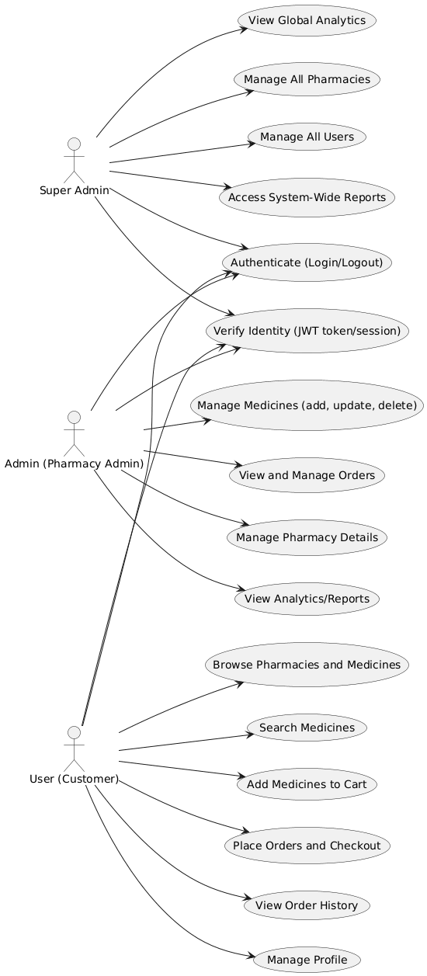

## System Architecture Diagram

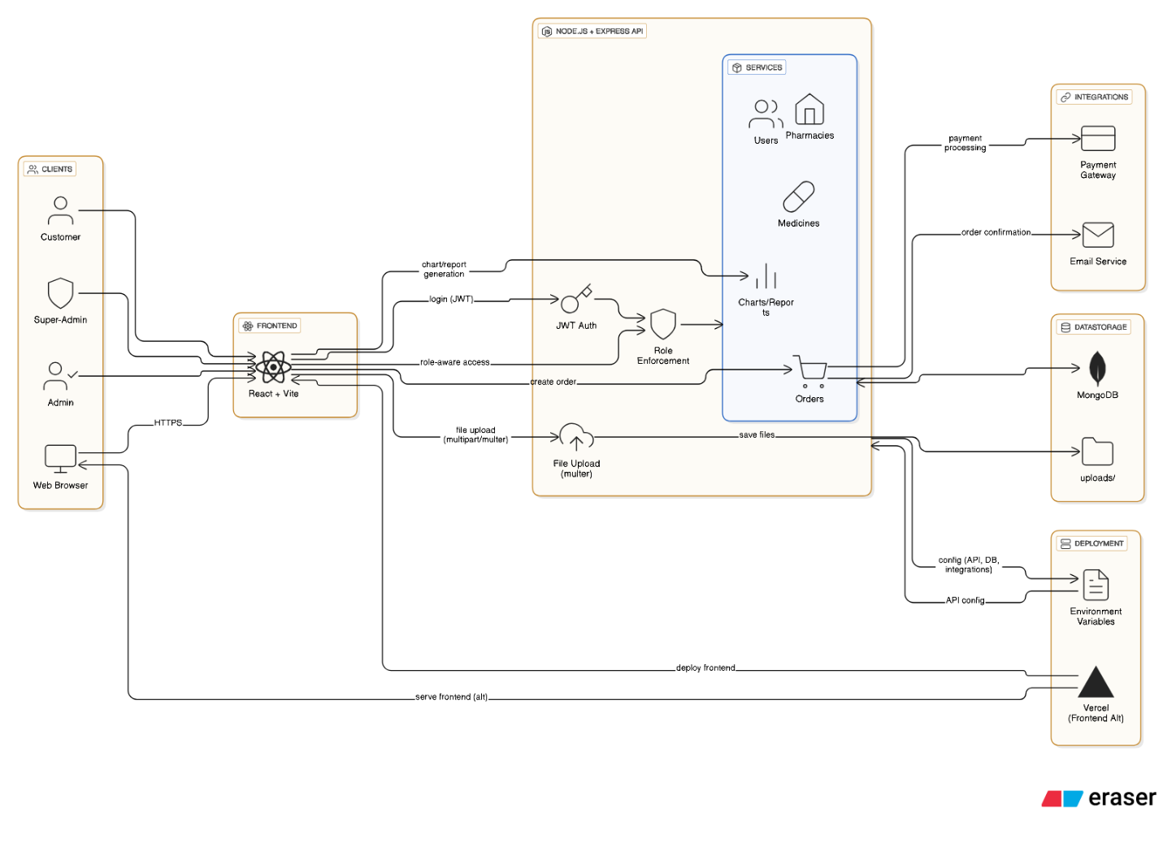

# **Design Phase**

## ERD Diagram (Database Design)

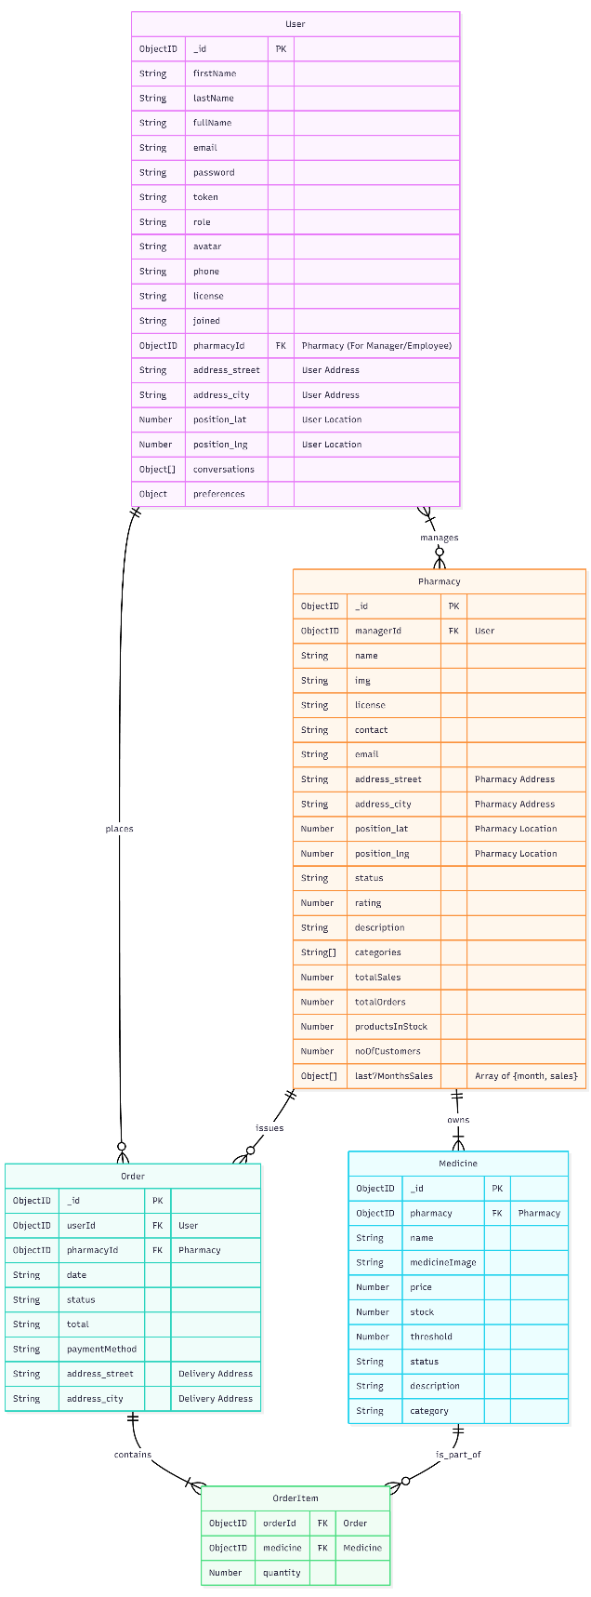

## Database Schema

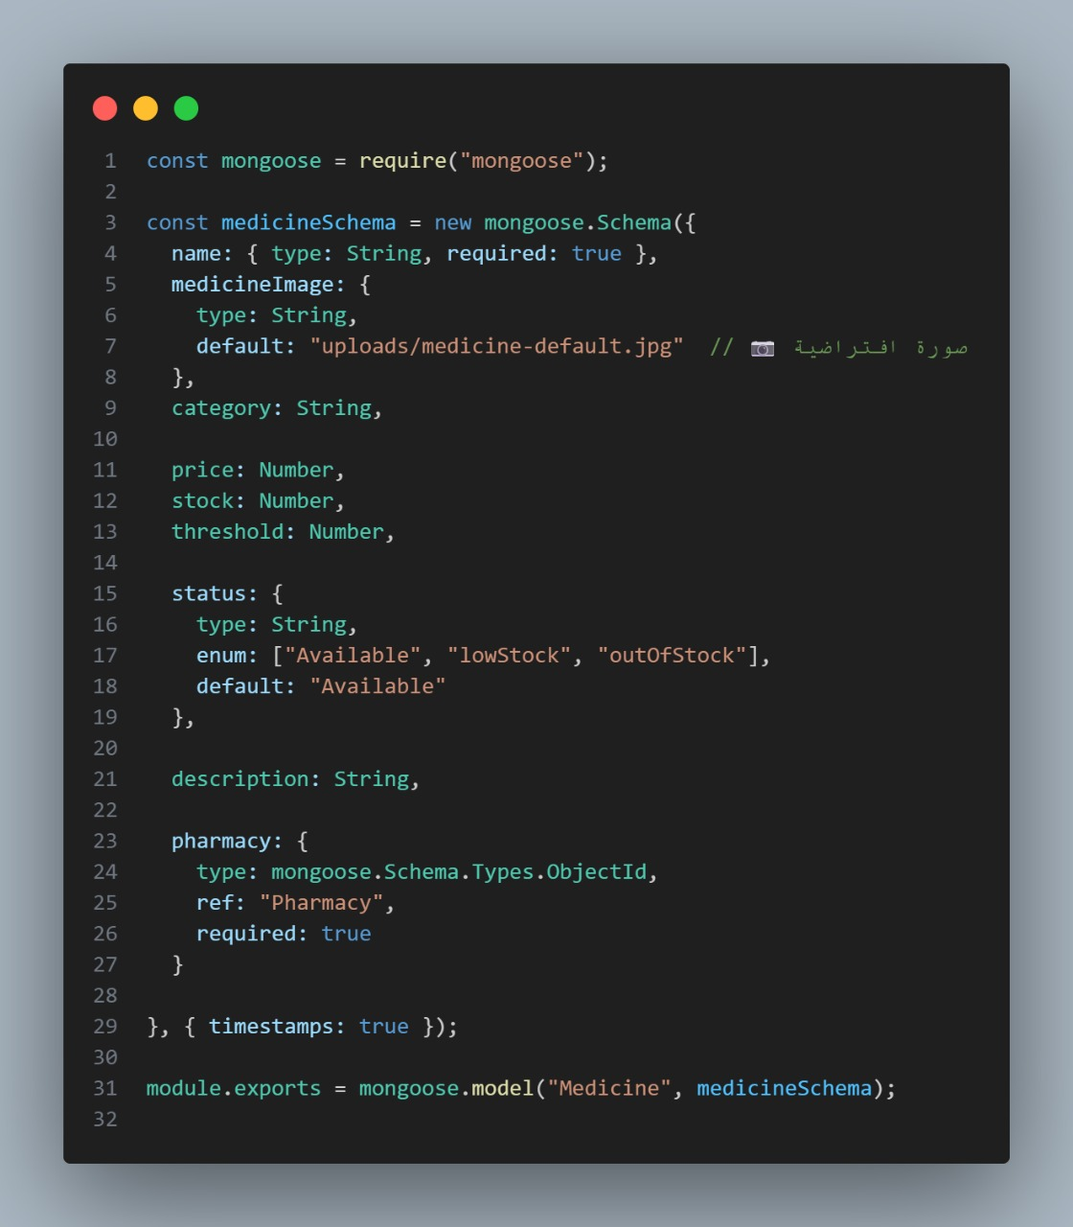

* + *MEDICNE SCHEMA*

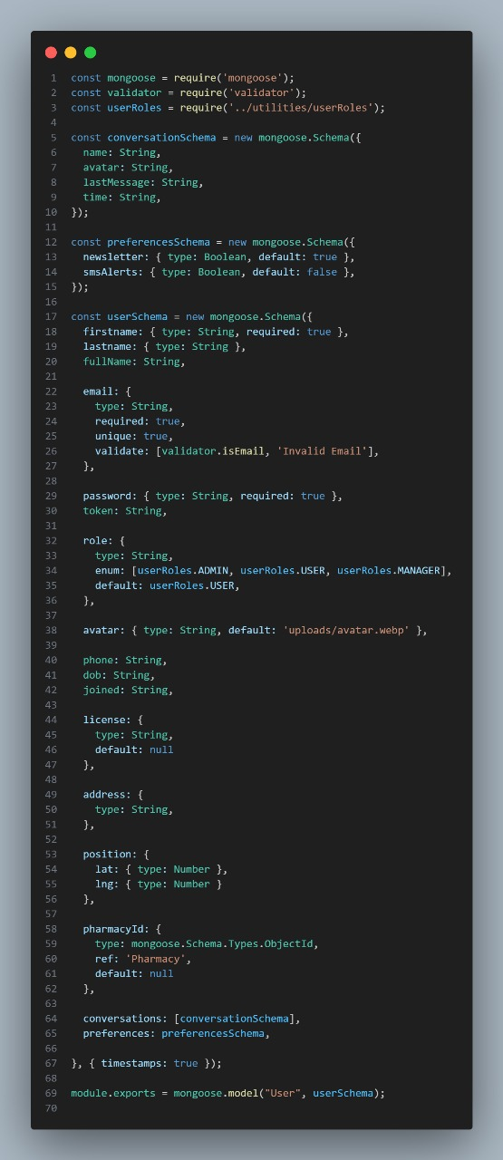

* + *PHARMACY SCHEMA*

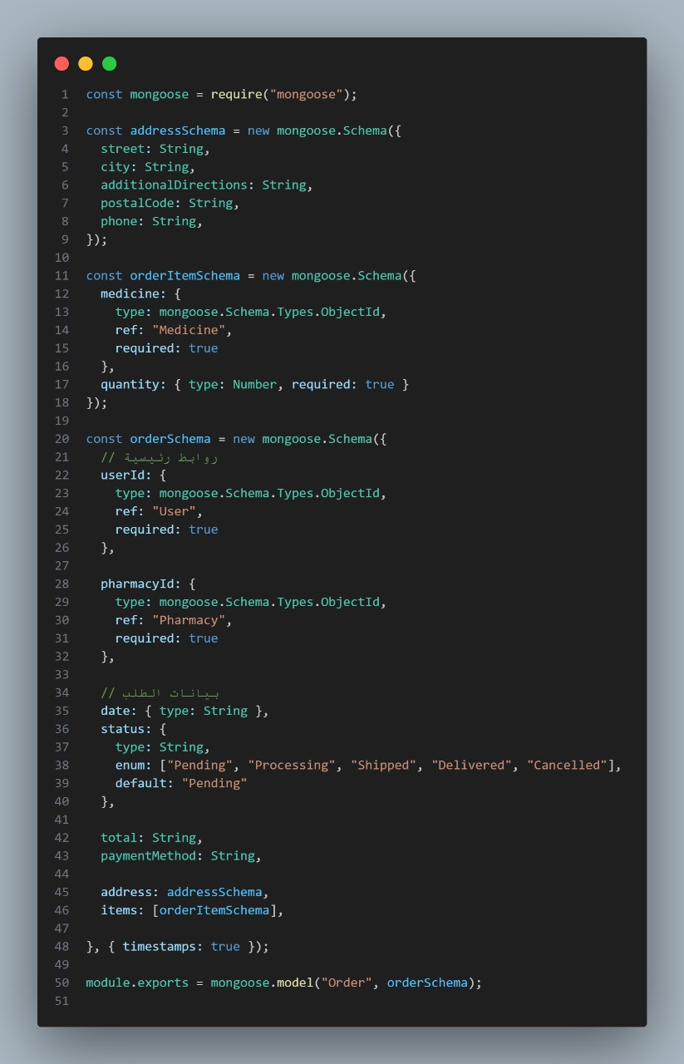

* + *ORDER SCHEMA*



* + *USER SCHMA*

## Component Diagram

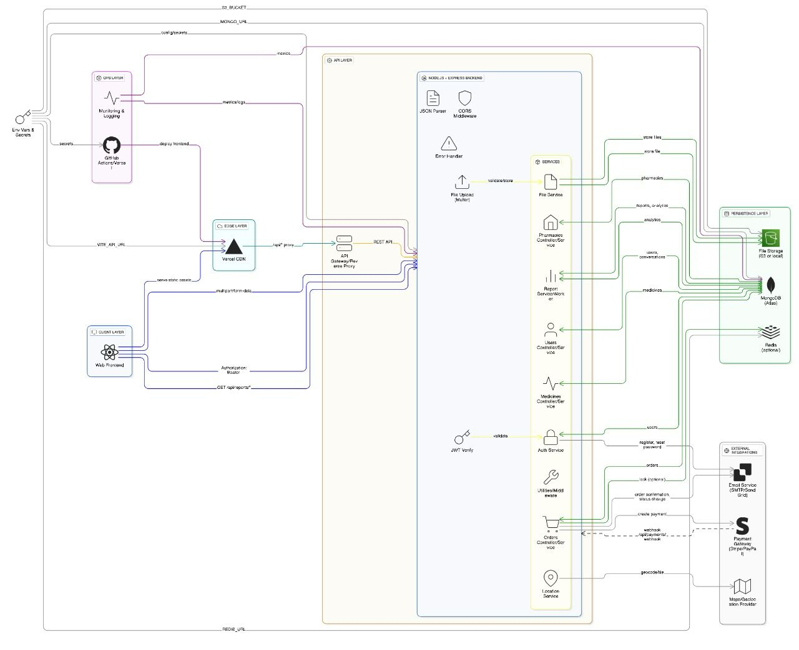

## UI/UX Design

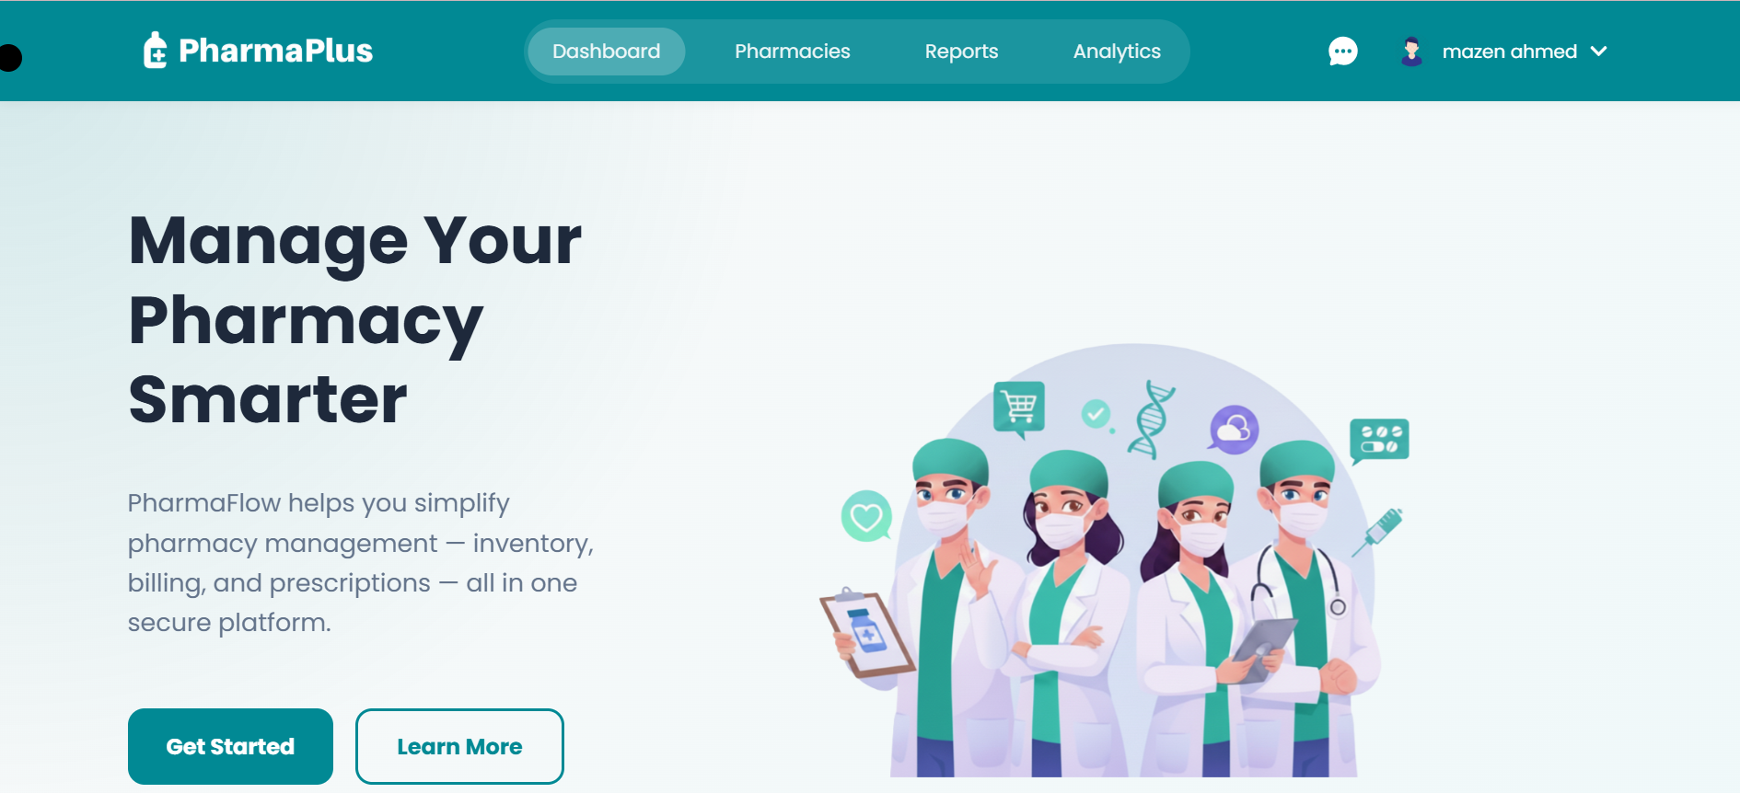



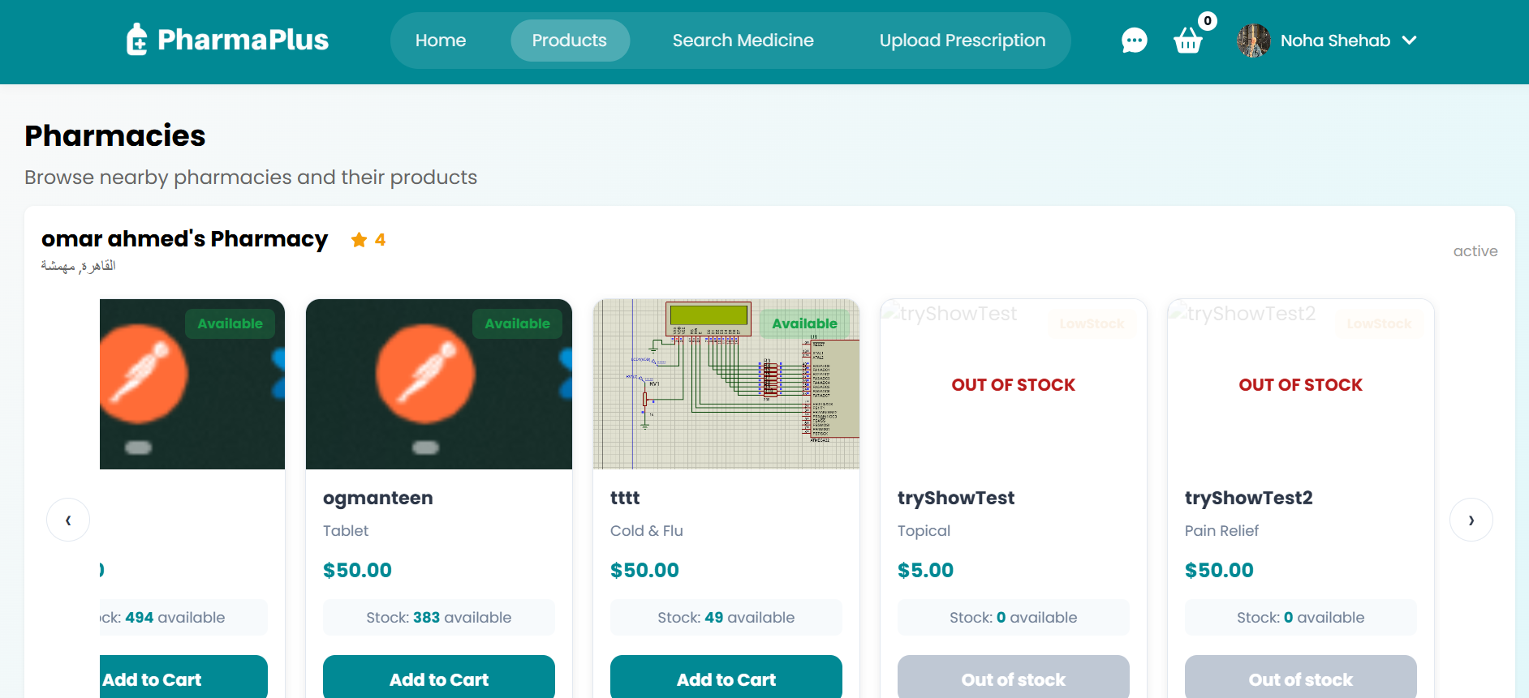

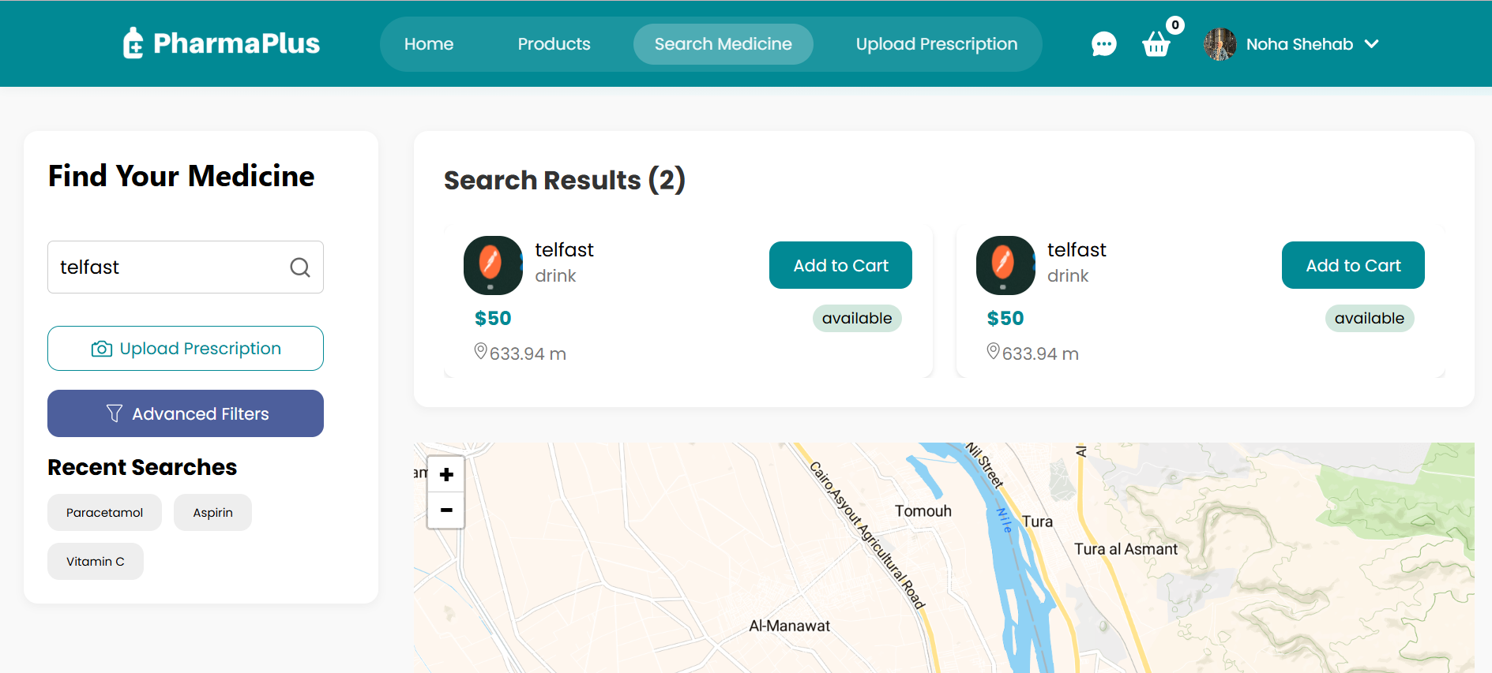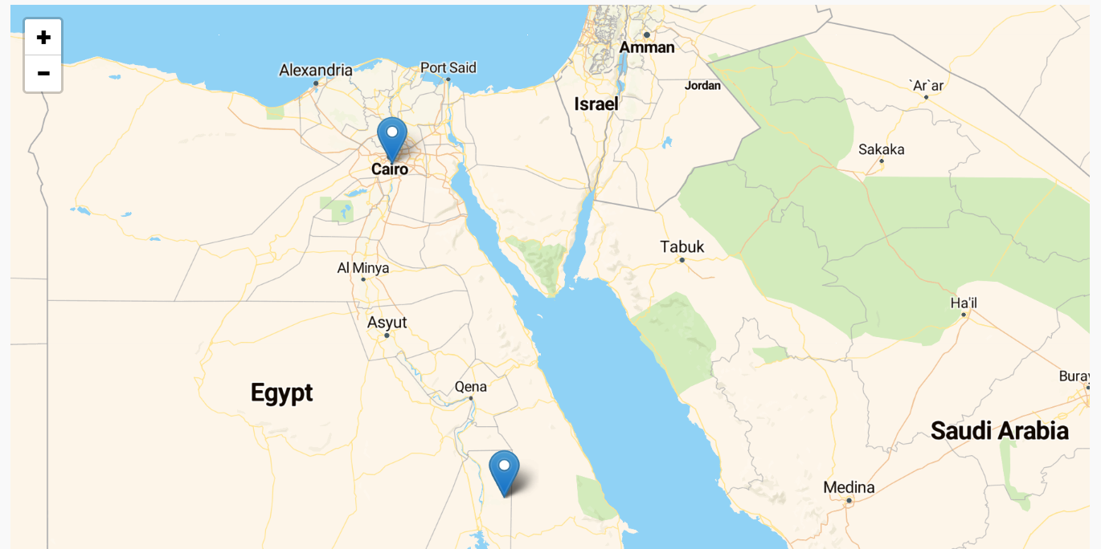

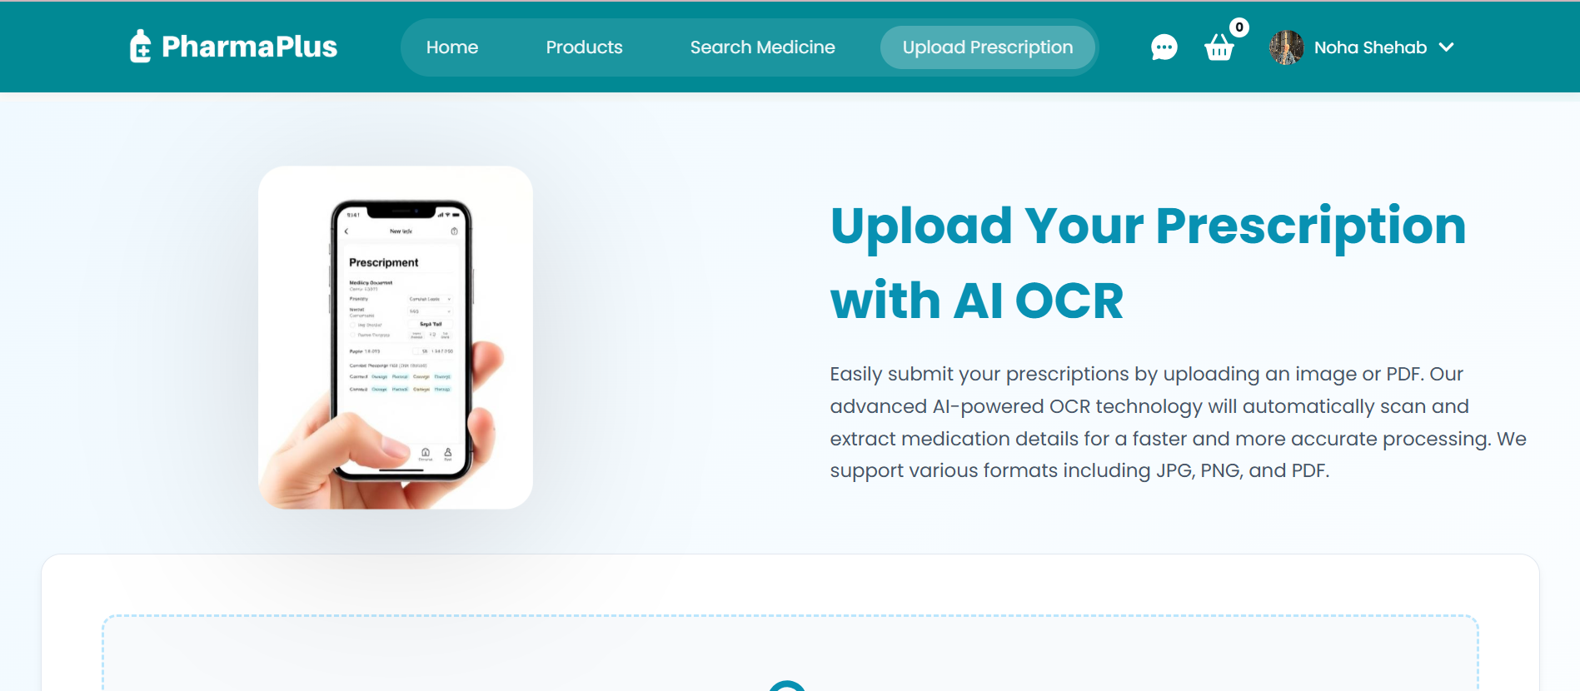

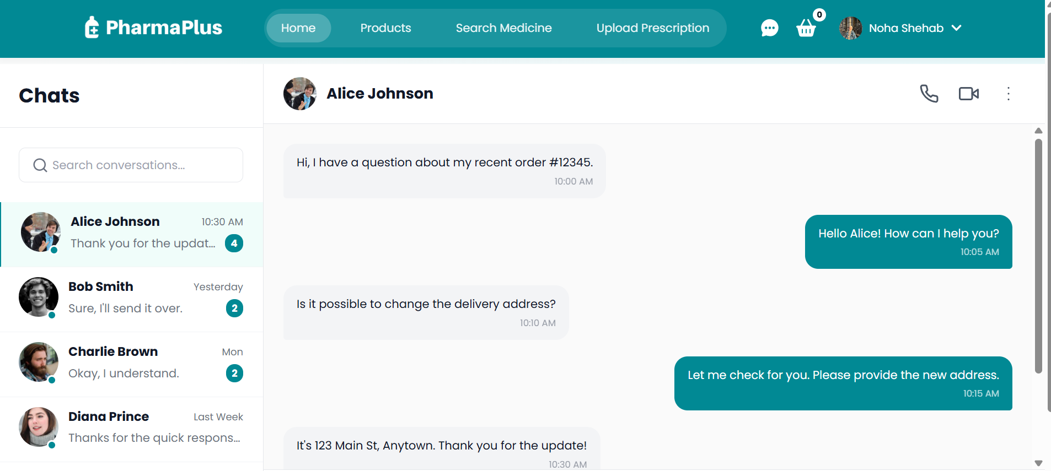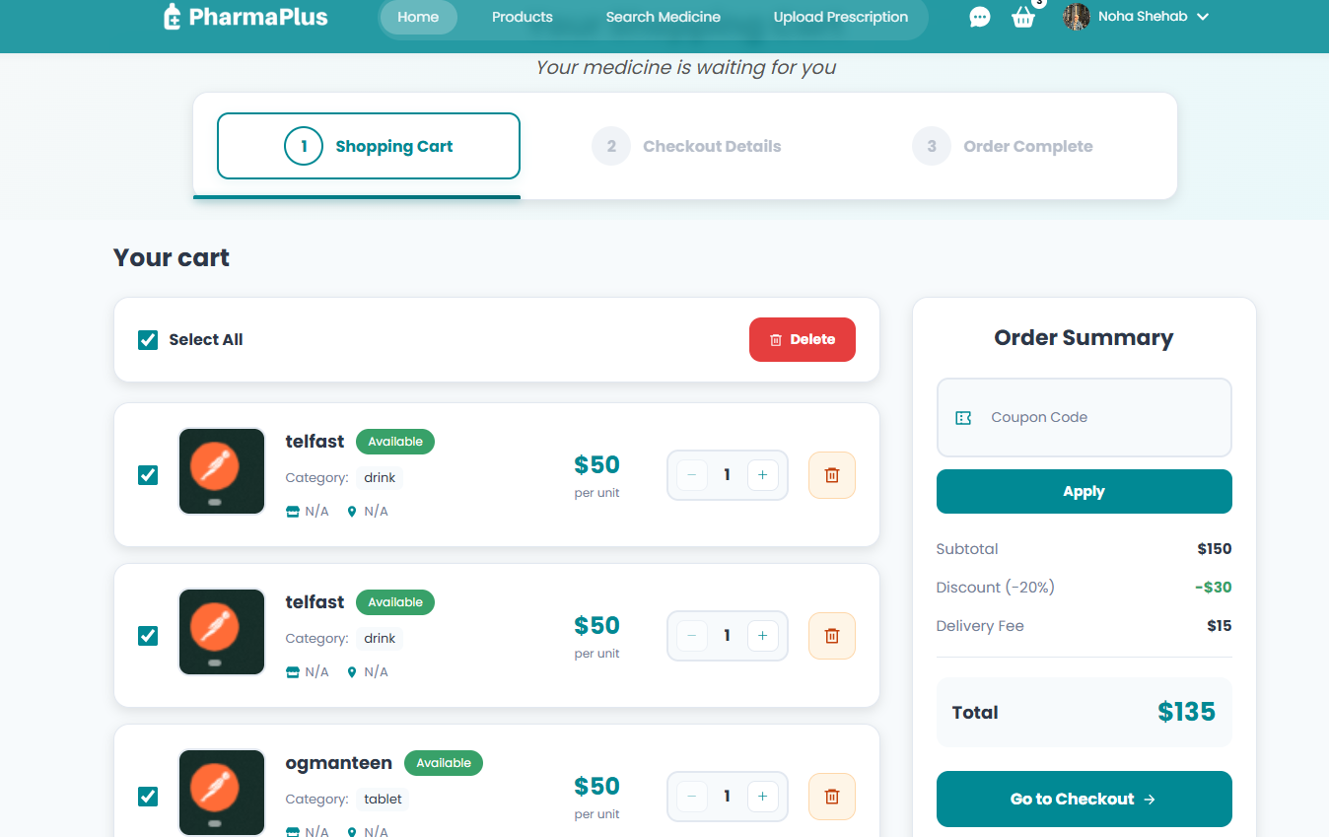

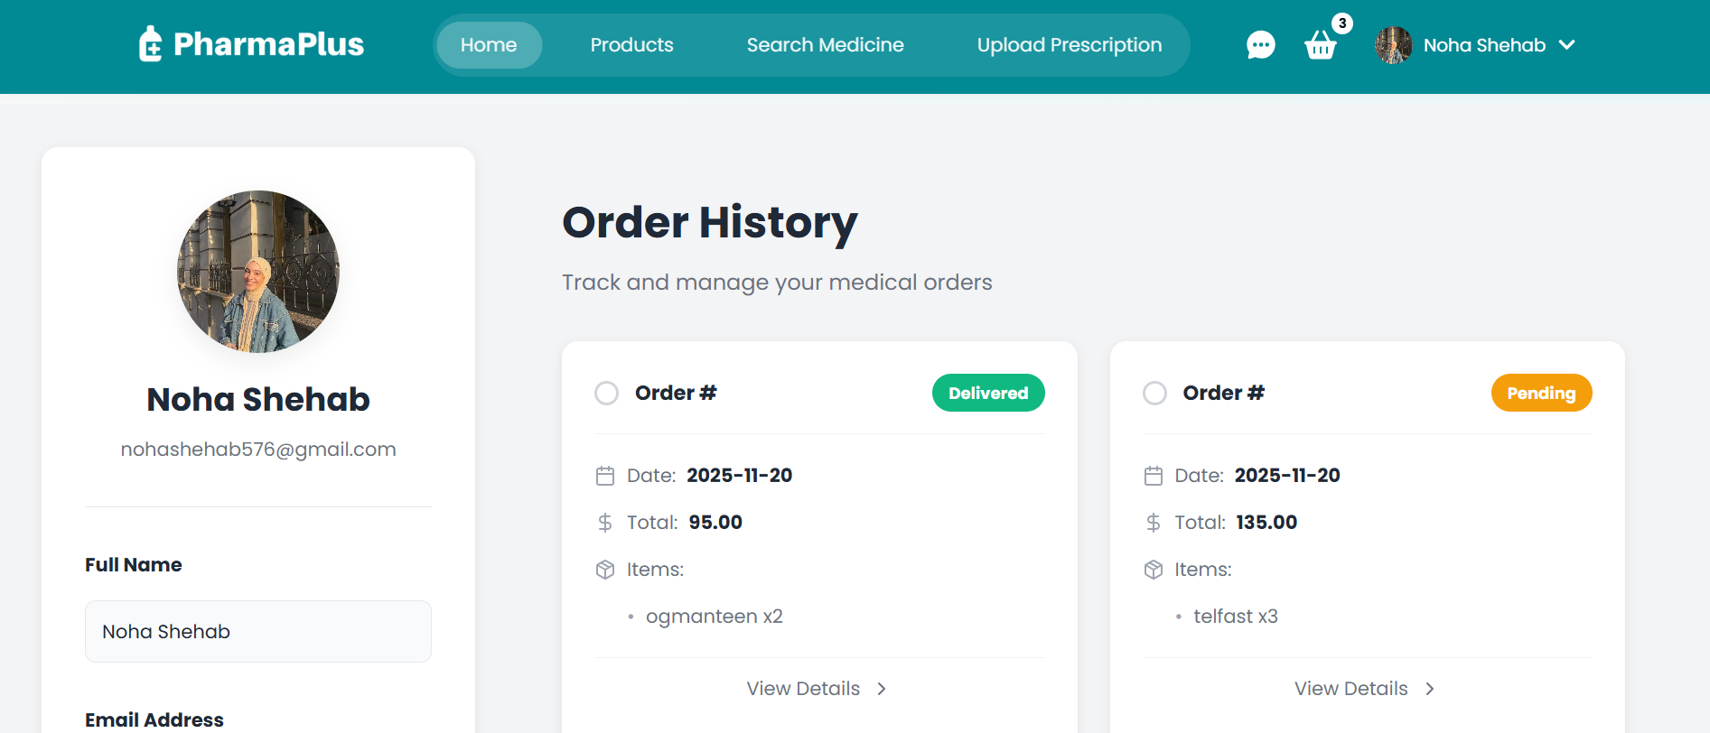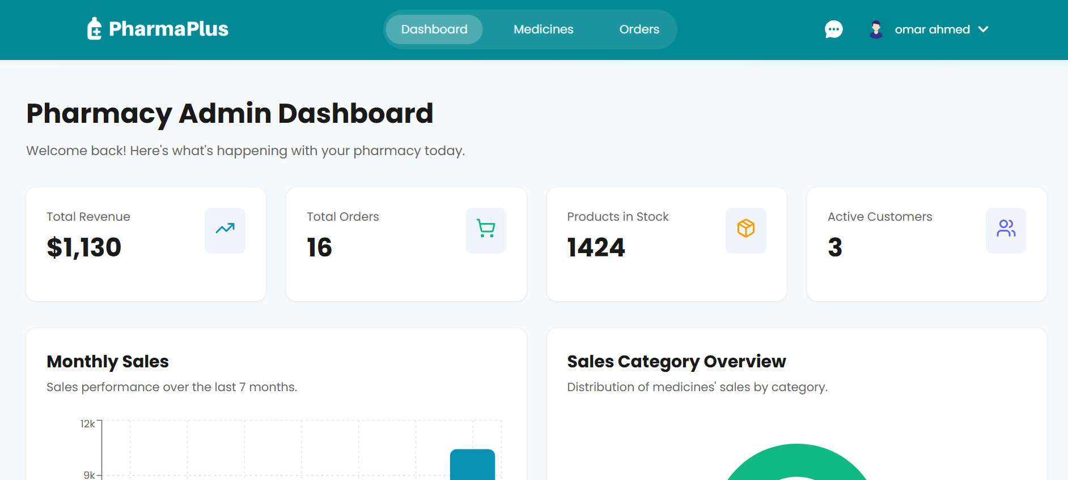

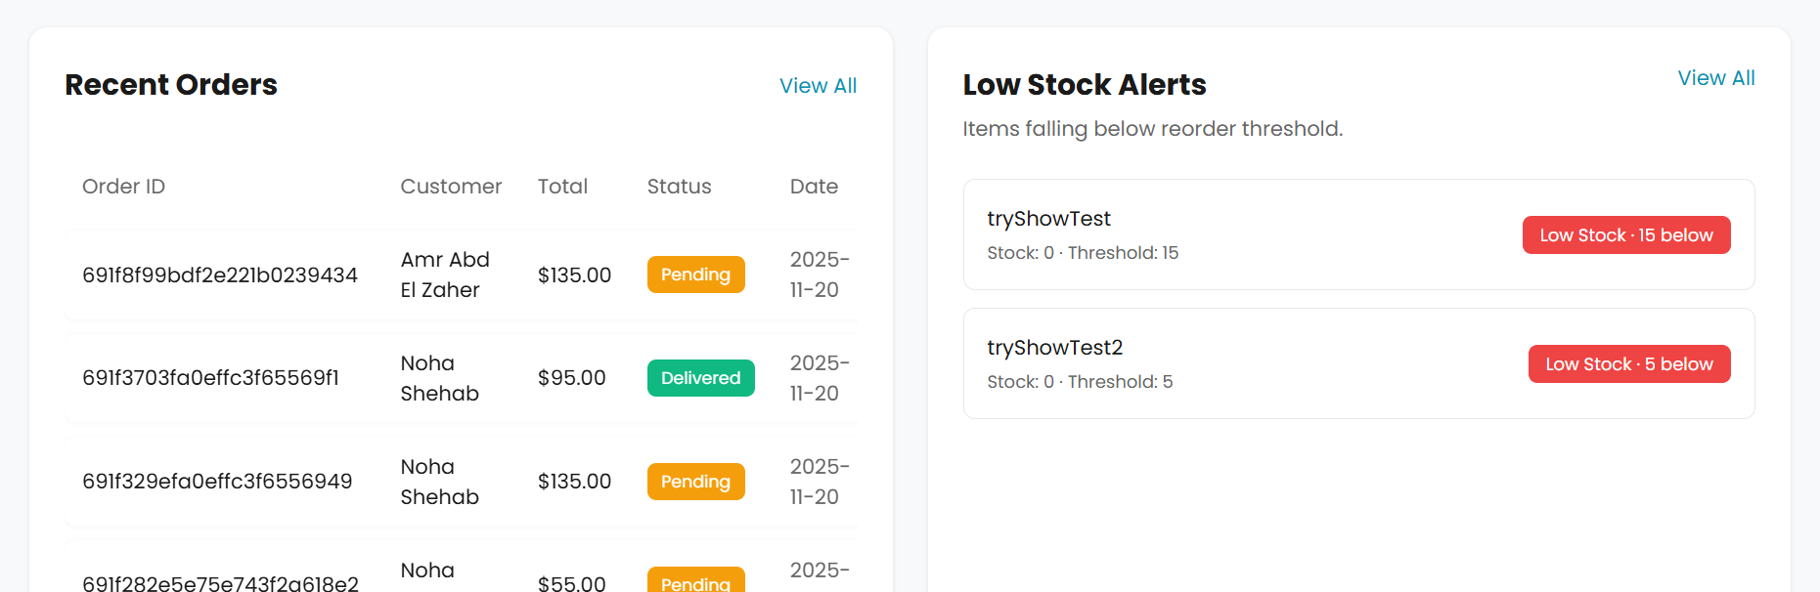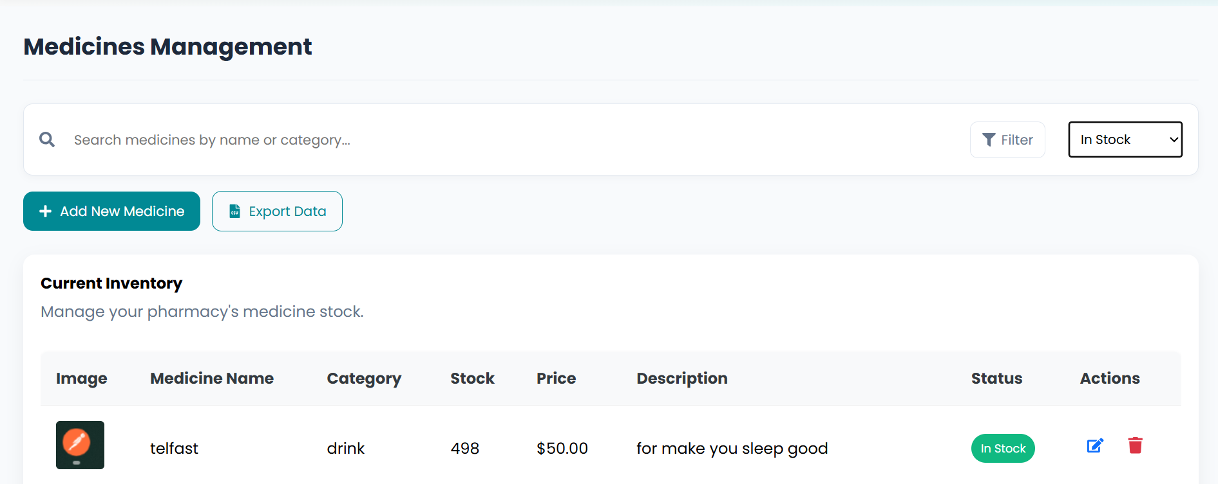

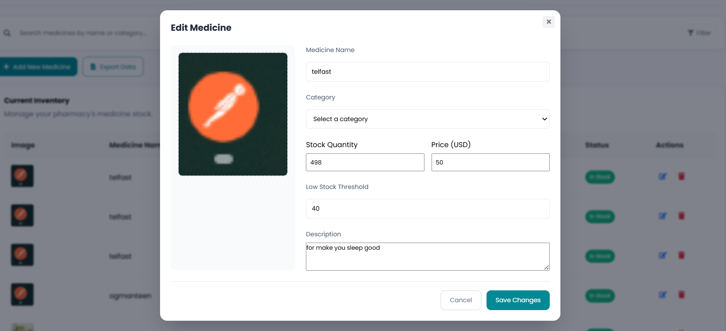

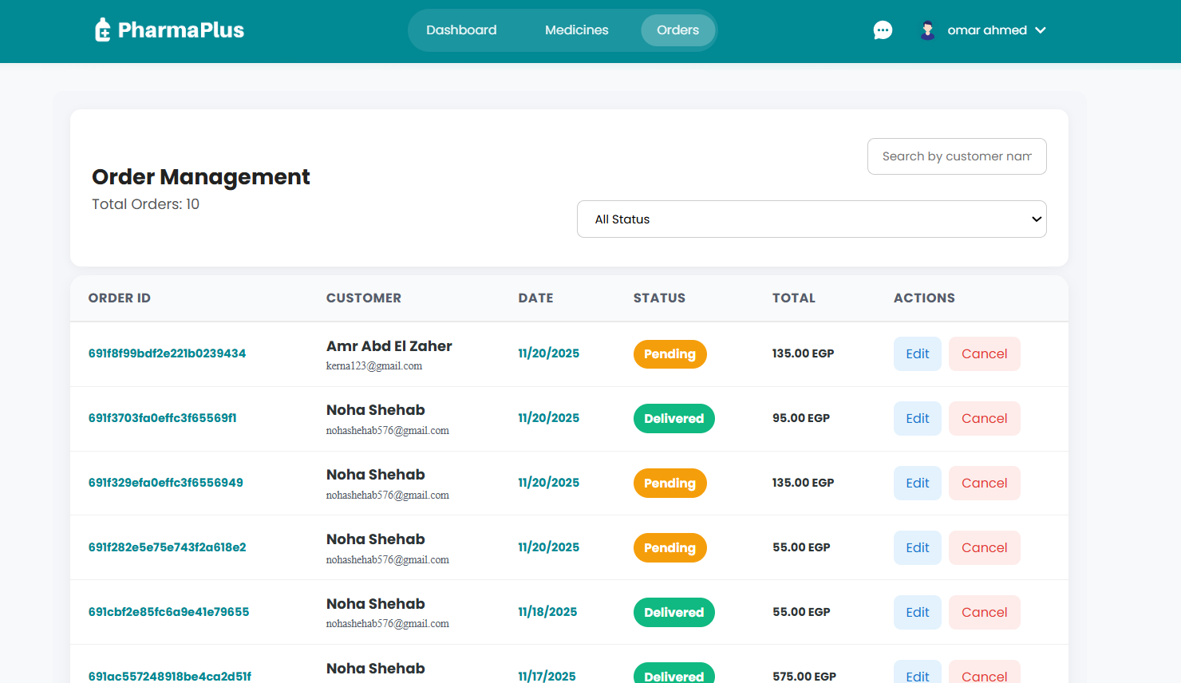

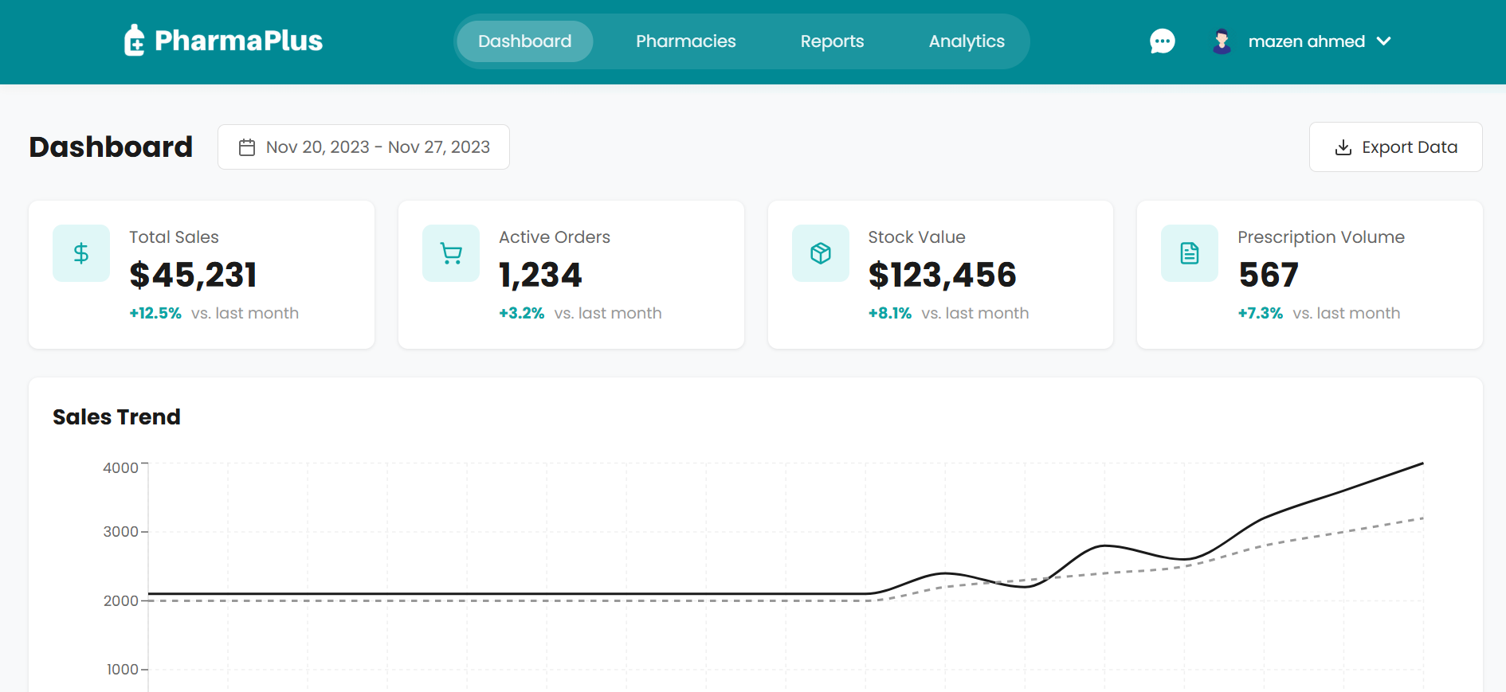

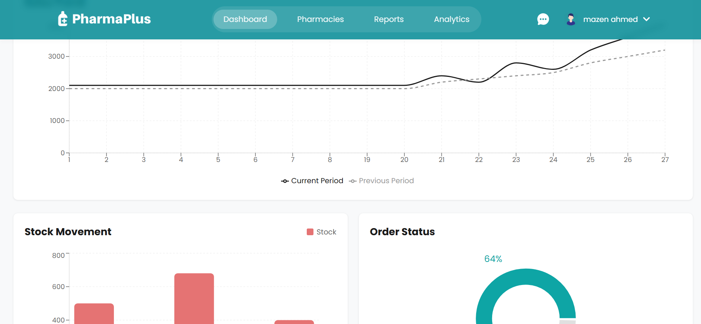

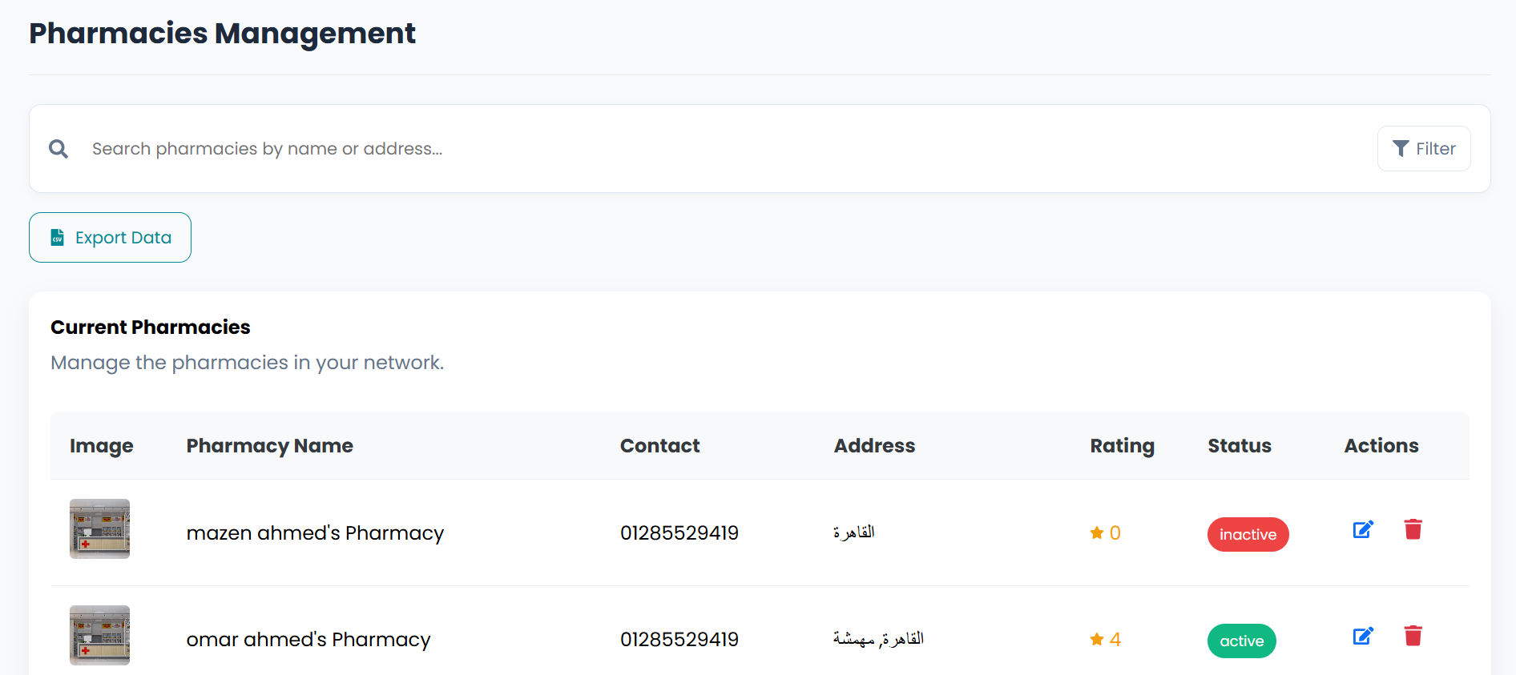

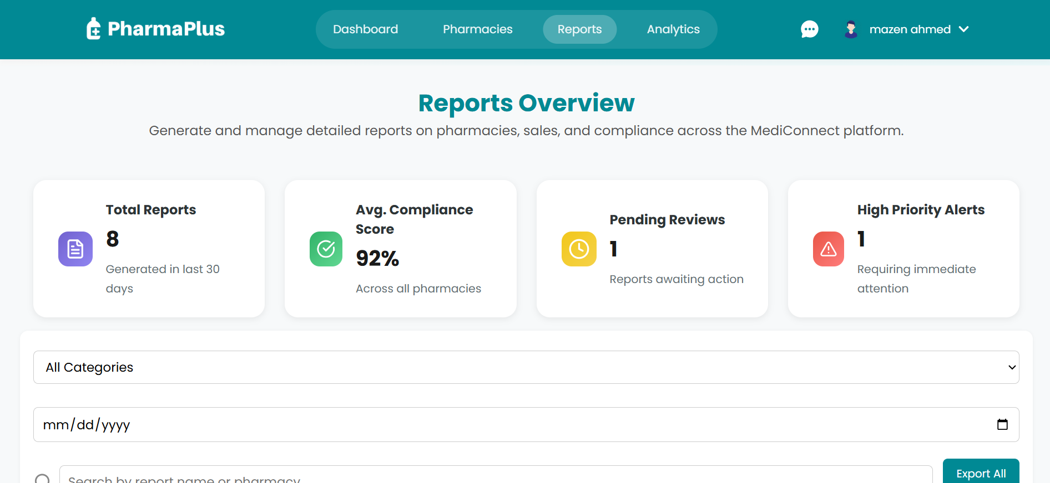

**Link:**

[**https://app.visily.ai/projects/e99bd257-8210-44e0-a80a-924356e6db11/boards/2208800**](https://app.visily.ai/projects/e99bd257-8210-44e0-a80a-924356e6db11/boards/2208800)

# **Implementation Phase**

## Technologies & Tools Used

|  |  |
| --- | --- |
| **Category** | **Technologies** |
| **Frontend** | React 19, Vite |
| **Routing** | React Router DOM 7 |
| **State Management** | Context API, React Hooks |
| **UI & Styling** | CSS Modules, Framer Motion, Lucide React |
| **Analytics & Charts** | Recharts |
| **Mapping** | Leaflet, React-Leaflet |
| **Geolocation** | HTML5 Geolocation API |
| **Realtime Communication** | Socket.io |
| **Backend Runtime** | Node.js, Express.js |
| **Database** | MongoDB, Mongoose |
| **Authentication** | JWT, bcryptjs |
| **API Testing** | Postman |
| **Testing Tools** | React Testing Library (optional) |
| **Build Tools** | Npm , Vite Build |
| **Package Manager** | npm |
| **Quality Tools** | ESLint, , Nodemon |
| **Version Control** | Git, GitHub |
| **Deployment** | Vercel |
| **Development Tools** | VS Code, Chrome DevTools |
| **External APIs** | OpenStreetMap (Leaflet) |

## System Modules

**Backend Modules**

* **User Model & Controller**
  + Handles user registration, authentication (JWT), roles (admin, super admin, customer), and profile management.
  + Validates input, hashes passwords, and manages user sessions.
* **Pharmacy Model & Controller**
  + Represents pharmacies with fields like name, license, contact, address, status, manager, and sales stats.
  + Supports CRUD operations, pharmacy activation, and links to medicines and orders.
* **Medicine Model & Controller**
  + Manages medicines: name, price, stock, category, pharmacy reference, and image.
  + Enables admins to add, update, or remove medicines.
* **Order Model & Controller**
  + Handles order creation, status updates, linking users, pharmacies, and medicines.
  + Tracks order status (pending, processing, shipped, delivered, cancelled) and payment.
* **Middleware**
  + Authenticates requests (JWT), checks user roles, validates input, and handles errors.
* **Utilities**
  + HTTP status text, user roles, and async wrappers for error handling.

**Frontend Modules**

* **Authentication & Context**
  + AuthContext and useAuth manage user state, login/logout, and token storage.
  + Centralized state for user info, roles, and authentication status.
* **Dashboard Modules**
  + Admin and Super Admin dashboards show stats, charts (Recharts), and tables for sales, stock, and pharmacy analytics.
  + Components: [StatCard](vscode-file://vscode-app/c:/Users/nohas/AppData/Local/Programs/Microsoft%20VS%20Code/resources/app/out/vs/code/electron-browser/workbench/workbench.html), [MonthlySalesChart](vscode-file://vscode-app/c:/Users/nohas/AppData/Local/Programs/Microsoft%20VS%20Code/resources/app/out/vs/code/electron-browser/workbench/workbench.html), [StockCategoryChart](vscode-file://vscode-app/c:/Users/nohas/AppData/Local/Programs/Microsoft%20VS%20Code/resources/app/out/vs/code/electron-browser/workbench/workbench.html), [RecentOrdersTable](vscode-file://vscode-app/c:/Users/nohas/AppData/Local/Programs/Microsoft%20VS%20Code/resources/app/out/vs/code/electron-browser/workbench/workbench.html), [LowStockAlerts](vscode-file://vscode-app/c:/Users/nohas/AppData/Local/Programs/Microsoft%20VS%20Code/resources/app/out/vs/code/electron-browser/workbench/workbench.html).
* **Cart & Order Modules**
  + Components for cart items, checkout, order summary, and order completion.
  + State managed via context for cart and orders.
* **Pharmacy & Medicine Management**
  + Admins can add/edit pharmacies and medicines via modals and tables.
  + Components: PharmacyTable, MedicineTable, AddPharmacyModal, AddMedicineModal.
* **Reports & Analytics**
  + Super Admin analytics: user growth, revenue, pharmacy performance (charts, tables).
  + Reports overview: summary cards, filter, and export features.
* **UI Components**
  + Navbar, navigation menu, role-based links, chat, notifications, and responsive design.
  + CSS Modules for scoped, maintainable styles.

## Folder Structure

PharmaPlus/

├── package.json

├── vite.config.js

├── index.html

└── src/

├── app/ # Main App setup and providers

├── components/ # Reusable UI components

├── context/ # Global state (Auth, Cart, Products)

├── hooks/ # Custom hooks

├── layouts/ # Application layouts

├── pages/ # Page-level components (Admin, SuperAdmin, Customer…)

├── routes/ # Route guards and navigation

├── shared/ # Shared utilities and API handlers

└── assets/ # Images and static assets

PharmaPlus_backend/

├── controllers/ # Business logic for each feature

│ ├── users.controller.js

│ ├── medicine.controller.js

│ ├── pharmacy.controller.js

│ ├── order.controller.js

│ └── dashboard.controller.js

├── models/ # MongoDB schemas

│ ├── user.model.js

│ ├── medicine.model.js

│ ├── pharmacy.model.js

│ ├── order.model.js

│ └── stockAlert.model.js

├── routs/ # API route definitions

│ ├── users.rout.js

│ ├── medicines.rout.js

│ ├── pharmacies.rout.js

│ ├── orders.rout.js

│ └── analytics_suepr.rout.js

├── middleware/ # Express middleware

│ ├── asyncwrapper.js # Async error handling

│ ├── verifytoken.js # JWT verification

│ ├── allowedto.js # Role-based access control

│ └── validationschema.js

├── services/ # Business logic services

│ ├── analytics_super.service.js

│ ├── location.service.js

│ └── pharmacyAnalytics(admin).service.js

├── utilities/ # Helper functions

│ ├── httpstatustext.js

│ ├── userRoles.js

│ └── date.helper.js

├── uploads/ # User uploaded files

├── index.js # Server entry point

├── package.json # Dependencies

└── .env # Environment configuration

## Code Samples

**Frontend: Authentication Context**

import React, { createContext, useState, useCallback } from 'react';  
  
export const AuthContext = createContext();  
  
export const AuthProvider = ({ children }) => {  
 const [user, setUser] = useState(null);  
  
 const login = useCallback(async (email, password) => {  
 const response = await fetch('/api/users/login', {  
 method: 'POST',  
 headers: { 'Content-Type': 'application/json' },  
 body: JSON.stringify({ email, password }),  
 });  
 const data = await response.json();  
 setUser(data.user);  
 localStorage.setItem('token', data.token);  
 }, []);  
  
 const logout = () => {  
 setUser(null);  
 localStorage.removeItem('token');  
 };  
  
 return (  
 <AuthContext.Provider value={{ user, login, logout }}>  
 {children}  
 </AuthContext.Provider>  
 );  
};

**Frontend: Example UI Component – Cart Item**

const CartItem = ({ item, onRemove, onQuantityChange }) => {

return (

<div className="cartItem">

<h4>{item.name}</h4>

<p>{item.description}</p>

<div className="quantity">

<button onClick={() => onQuantityChange(item.id, item.quantity - 1)}>-</button>

<span>{item.quantity}</span>

<button onClick={() => onQuantityChange(item.id, item.quantity + 1)}>+</button>

</div>

<button onClick={() => onRemove(item.id)}>Remove</button>

</div>

);

};

**Frontend: Analytics Example – Monthly Sales Chart**

import { BarChart, Bar, XAxis, YAxis, Tooltip, ResponsiveContainer } from 'recharts';

const MonthlySalesChart = ({ data }) => (

<ResponsiveContainer width="100%" height={300}>

<BarChart data={data}>

<XAxis dataKey="month" />

<YAxis />

<Tooltip />

<Bar dataKey="sales" fill="#8884d8" />

</BarChart>

</ResponsiveContainer>

);

**Frontend: Example Map Component (Leaflet)**

import { MapContainer, TileLayer, Marker } from 'react-leaflet';

const PharmacyMap = () => (

<MapContainer center={[30.0444, 31.2357]} zoom={7} style={{ height: '500px' }}>

<TileLayer url="https://{s}.tile.openstreetmap.org/{z}/{x}/{y}.png" />

<Marker position={[30.05, 31.23]} />

</MapContainer>

);

**Frontend : Example LoginModal**

import React, { useState } from "react";

import { useAuth } from "../../../hooks/useAuth";

import postLogin from "../../../shared/api/postLogin";

export default function LoginModal() {

const { loginWithToken } = useAuth();

const [email, setEmail] = useState("");

const [password, setPassword] = useState("");

const handleLogin = async (e) => {

e.preventDefault();

const res = await postLogin({ email, password });

await loginWithToken(res.data.token);

};

return (

<form onSubmit={handleLogin}>

<input type="email" placeholder="Email" onChange={(e)=>setEmail(e.target.value)} />

<input type="password" placeholder="Password" onChange={(e)=>setPassword(e.target.value)} />

<button>Login</button>

</form>

);

}

**Backend: Login Controller**

exports.login = async (req, res) => {  
 const { email, password } = req.body;  
 const user = await Users.findOne({ email }).select('+password');  
  
 const valid = await bcrypt.compare(password, user.password);  
 const token = jwt.sign({ id: user._id, role: user.role }, process.env.JWT_SECRET);  
  
 res.json({ user, token });  
};

**Backend: JWT Middleware**

module.exports = (req, res, next) => {  
 const token = req.headers.authorization?.split(' ')[1];  
 const decoded = jwt.verify(token, process.env.JWT_SECRET);  
 req.user = decoded;  
 next();  
};

**Backend: Server Setup**

const app = express();

app.use(express.json());

app.use('/api/users', require('./routs/users.rout'));

mongoose.connect(process.env.MONGO_URL);

app.listen(process.env.PORT || 3000);

## API Documentation

### **Overview**

The PharmaPlus backend provides a **RESTful API** for **user management, pharmacy and medicine operations, order processing, analytics, and file uploads.**

All protected endpoints require **JWT authentication** via the Authorization: Bearer <token> header.

File uploads (e.g., user avatars, pharmacy/medicine images) use [multipart/form-data](vscode-file://vscode-app/c:/Users/nohas/AppData/Local/Programs/Microsoft%20VS%20Code/resources/app/out/vs/code/electron-browser/workbench/workbench.html).

Pagination is supported for large GET requests using? limit and? page query parameters.

Standard error codes and messages are returned for all endpoints.

### **Users Endpoints (**[**/api/users**](vscode-file://vscode-app/c:/Users/nohas/AppData/Local/Programs/Microsoft%20VS%20Code/resources/app/out/vs/code/electron-browser/workbench/workbench.html)**)**

Register, login, get/update profile, list users, get/update/delete user by ID, add chat.

Example:

[POST /api/users/register](vscode-file://vscode-app/c:/Users/nohas/AppData/Local/Programs/Microsoft%20VS%20Code/resources/app/out/vs/code/electron-browser/workbench/workbench.html) — Register new user (with avatar upload)

[POST /api/users/login](vscode-file://vscode-app/c:/Users/nohas/AppData/Local/Programs/Microsoft%20VS%20Code/resources/app/out/vs/code/electron-browser/workbench/workbench.html) — Login, returns JWT and user info

[GET /api/users/profile](vscode-file://vscode-app/c:/Users/nohas/AppData/Local/Programs/Microsoft%20VS%20Code/resources/app/out/vs/code/electron-browser/workbench/workbench.html) — Get current user profile (auth required)

[PUT /api/users/profile](vscode-file://vscode-app/c:/Users/nohas/AppData/Local/Programs/Microsoft%20VS%20Code/resources/app/out/vs/code/electron-browser/workbench/workbench.html) — Update profile (auth required)

GET /api/users?limit=10&page=1 — List users (admin only)

[GET /api/users/:id](vscode-file://vscode-app/c:/Users/nohas/AppData/Local/Programs/Microsoft%20VS%20Code/resources/app/out/vs/code/electron-browser/workbench/workbench.html) — Get user by ID

[PUT /api/users/:id](vscode-file://vscode-app/c:/Users/nohas/AppData/Local/Programs/Microsoft%20VS%20Code/resources/app/out/vs/code/electron-browser/workbench/workbench.html) — Update user by ID

[DELETE /api/users/:id](vscode-file://vscode-app/c:/Users/nohas/AppData/Local/Programs/Microsoft%20VS%20Code/resources/app/out/vs/code/electron-browser/workbench/workbench.html) — Delete user by ID

[POST /api/users/:id/conversations](vscode-file://vscode-app/c:/Users/nohas/AppData/Local/Programs/Microsoft%20VS%20Code/resources/app/out/vs/code/electron-browser/workbench/workbench.html) — Store chat/contact history for a user

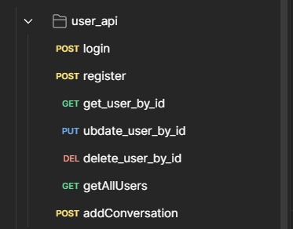

### **Medicines Endpoints (/api/medicines)**

CRUD for medicines, search, low stock, by pharmacy.

Example:

POST /api/medicines — Add new medicine (admin, with image upload)

GET /api/medicines — List all medicines

[GET /api/medicines/:id](vscode-file://vscode-app/c:/Users/nohas/AppData/Local/Programs/Microsoft%20VS%20Code/resources/app/out/vs/code/electron-browser/workbench/workbench.html) — Get medicine by ID

GET /api/medicines/search?name=aspirin — Search by name

[GET /api/medicines/low-stock](vscode-file://vscode-app/c:/Users/nohas/AppData/Local/Programs/Microsoft%20VS%20Code/resources/app/out/vs/code/electron-browser/workbench/workbench.html) — List low stock medicines

GET /api/medicines/pharmacy/:pharmacyId — Medicines for a pharmacy

[PUT /api/medicines/:id](vscode-file://vscode-app/c:/Users/nohas/AppData/Local/Programs/Microsoft%20VS%20Code/resources/app/out/vs/code/electron-browser/workbench/workbench.html) — Update medicine

[DELETE /api/medicines/:id](vscode-file://vscode-app/c:/Users/nohas/AppData/Local/Programs/Microsoft%20VS%20Code/resources/app/out/vs/code/electron-browser/workbench/workbench.html) — Delete medicine

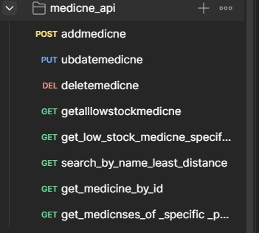

### **Pharmacies Endpoints (**[**/api/pharmacies**](vscode-file://vscode-app/c:/Users/nohas/AppData/Local/Programs/Microsoft%20VS%20Code/resources/app/out/vs/code/electron-browser/workbench/workbench.html)**)**

CRUD for pharmacies, dashboard, analytics, medicines by pharmacy.

Example:

[POST /api/pharmacies](vscode-file://vscode-app/c:/Users/nohas/AppData/Local/Programs/Microsoft%20VS%20Code/resources/app/out/vs/code/electron-browser/workbench/workbench.html) — Add new pharmacy (admin, with image upload)

[GET /api/pharmacies](vscode-file://vscode-app/c:/Users/nohas/AppData/Local/Programs/Microsoft%20VS%20Code/resources/app/out/vs/code/electron-browser/workbench/workbench.html) — List all pharmacies

[GET /api/pharmacies/:id](vscode-file://vscode-app/c:/Users/nohas/AppData/Local/Programs/Microsoft%20VS%20Code/resources/app/out/vs/code/electron-browser/workbench/workbench.html) — Get pharmacy by ID

[PUT /api/pharmacies/:id](vscode-file://vscode-app/c:/Users/nohas/AppData/Local/Programs/Microsoft%20VS%20Code/resources/app/out/vs/code/electron-browser/workbench/workbench.html) — Update pharmacy

[DELETE /api/pharmacies/:id](vscode-file://vscode-app/c:/Users/nohas/AppData/Local/Programs/Microsoft%20VS%20Code/resources/app/out/vs/code/electron-browser/workbench/workbench.html) — Delete pharmacy

GET /api/pharmacies/:id/medicines — Medicines in pharmacy

[GET /api/pharmacies/:id/dashboard](vscode-file://vscode-app/c:/Users/nohas/AppData/Local/Programs/Microsoft%20VS%20Code/resources/app/out/vs/code/electron-browser/workbench/workbench.html) — Pharmacy dashboard stats

GET /api/pharmacies/:id/top-medicines — Top medicines

GET /api/pharmacies/:id/sales-by-category — Sales by category

GET /api/pharmacies/:id/low-stock-alerts — Low stock alerts

GET /api/pharmacies/:id/customer-analytics — Customer analytics

GET /api/pharmacies/api/analytics-super — super analytics

### **Orders Endpoints (/api/orders)**

Create, list, update, delete orders, get by user/pharmacy.

Example:

GET /api/orders — Get all orders

POST /api/orders— Create a new order

GET /api/orders/:id — Get an order by its ID

GET /api/orders/user/:userId — Get orders for a specific user

GET /api/orders/pharmacy/:pharmacyId — Get orders for a specific pharmacy

PUT /api/orders/:id/status — Update order status (protected)

DELETE /api/orders/:id — Delete an order by ID

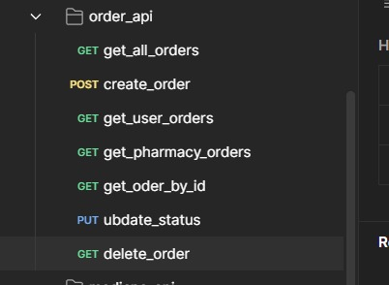

### **Request & Response Examples**

Standard API Response Format:

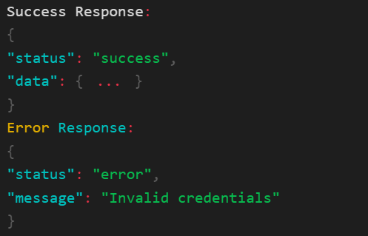

**Error Codes**

|  |  |
| --- | --- |
| **Code** | **Meaning** |
| 200 | Success |
| 201 | Created |
| 400 | Bad Request |
| 401 | Unauthorized |
| 403 | Forbidden |
| 404 | Not Found |
| 500 | Server Error |

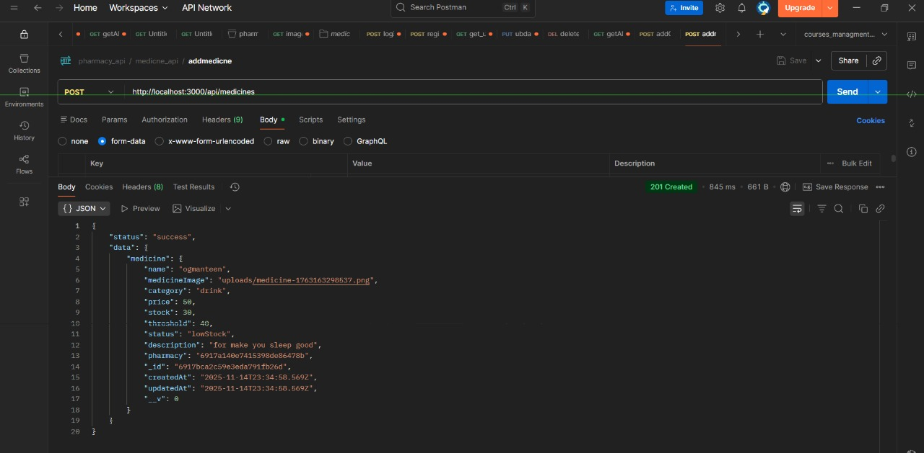

* + - **.**

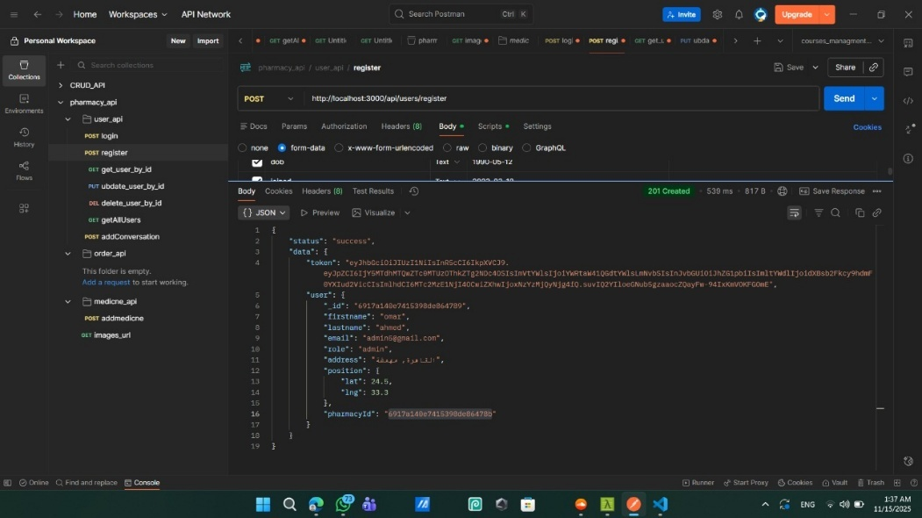

* + - **Register as admin**

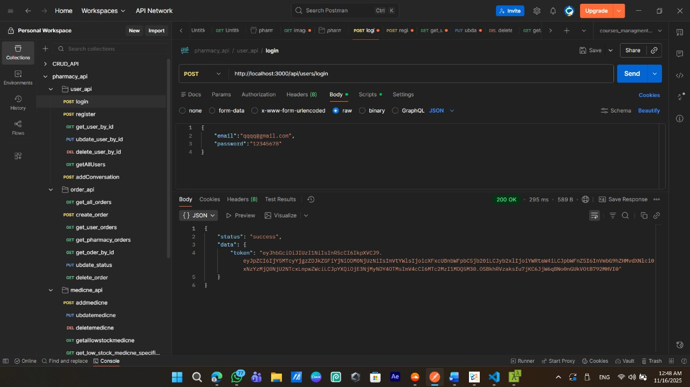

* + - **Login and Return Token**

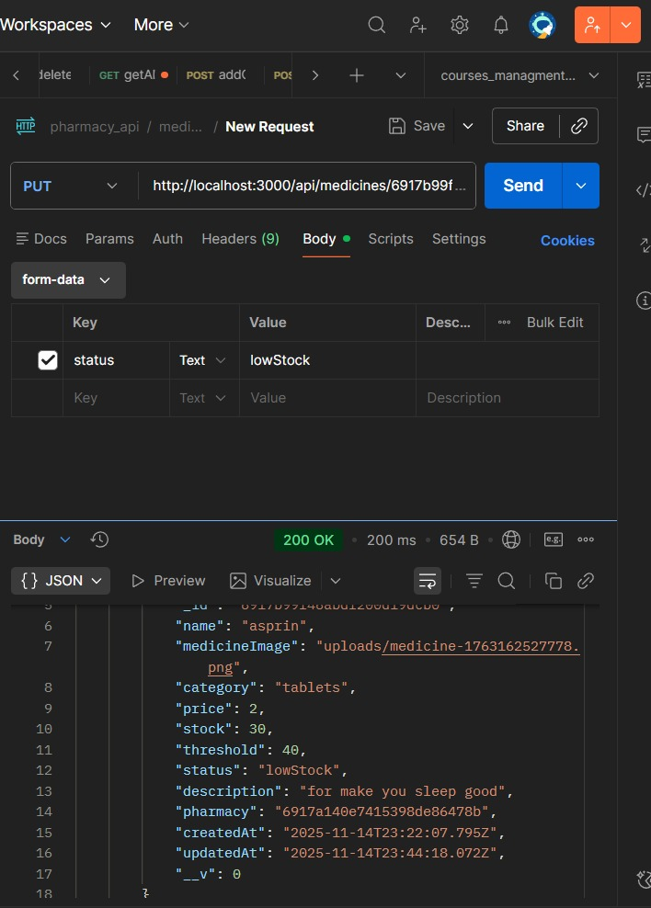

* + - **Update Medicine**

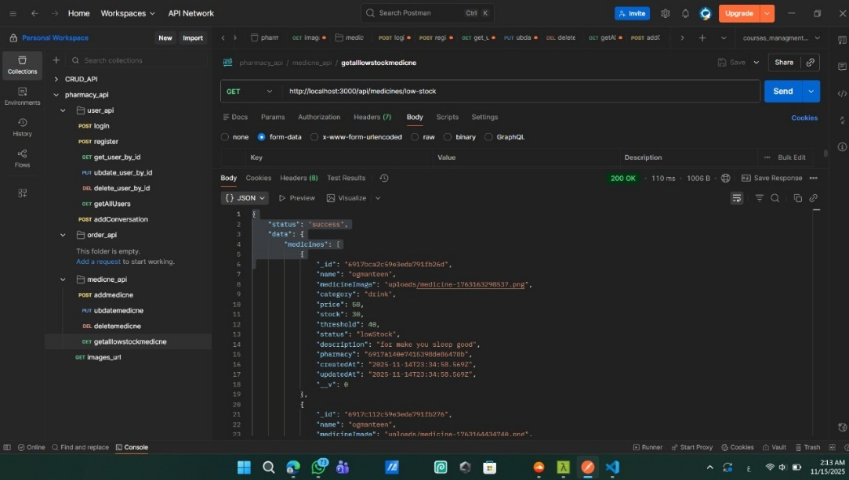

* + - **Get all low stock medicines in all pharmacies**

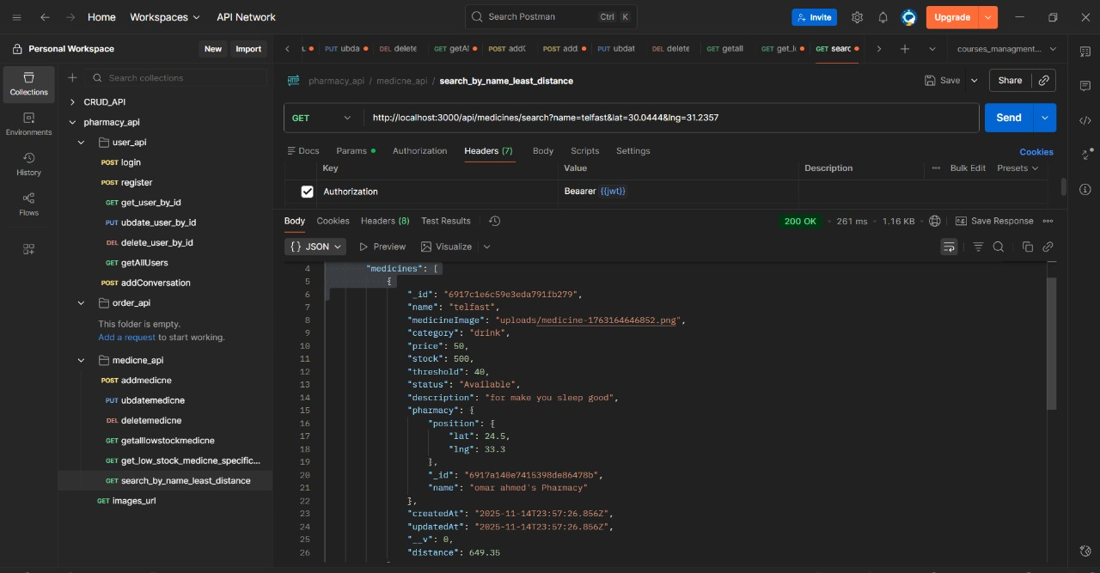

* + - **Search by name least distance**

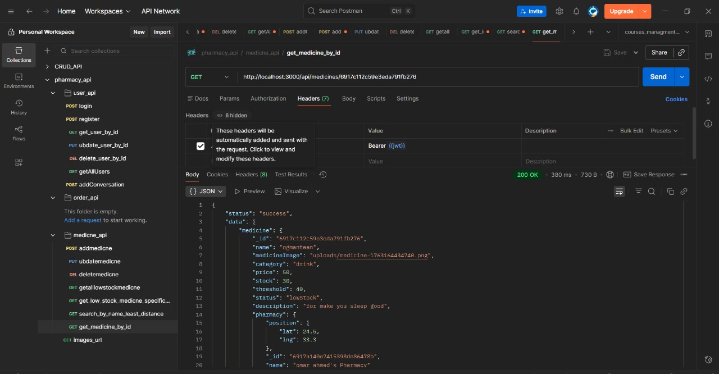

* + - **Get medicine by id**

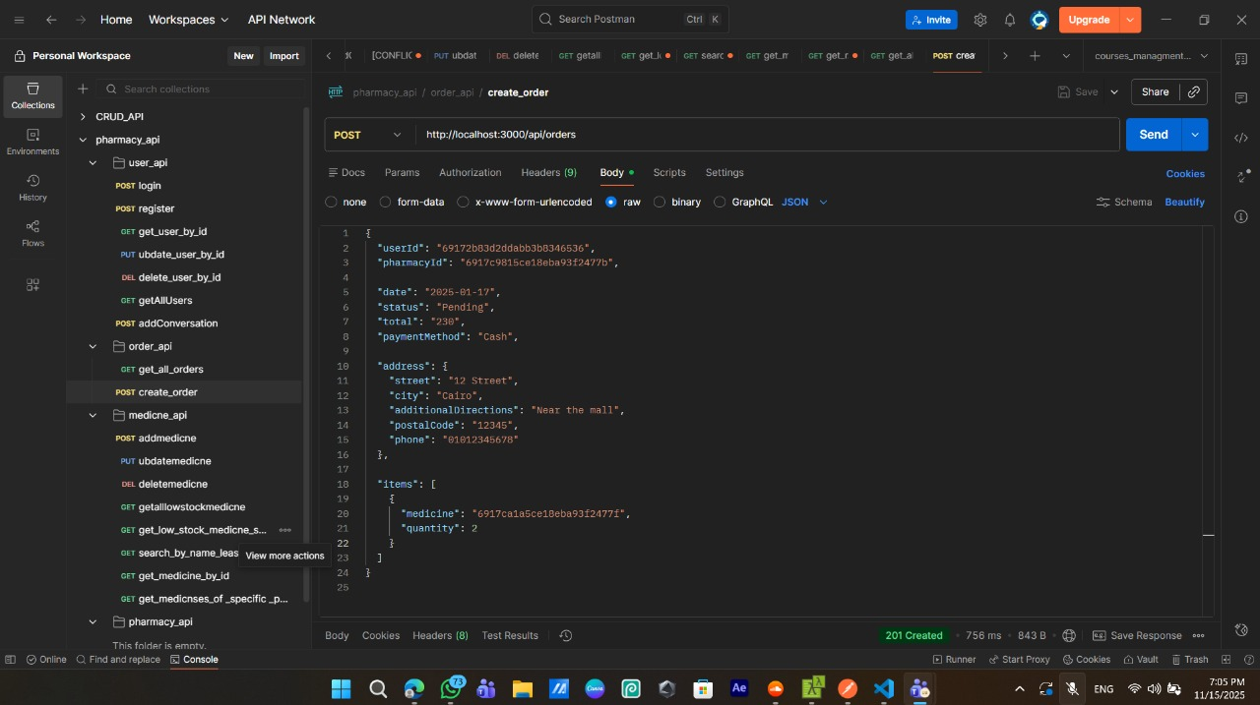

* + - **create order with all validation**

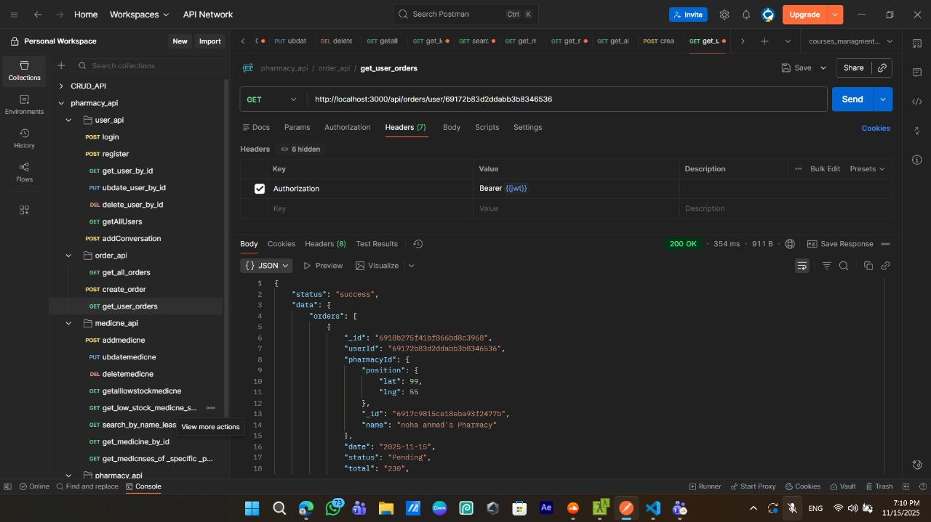

* + - **Get User Orders**

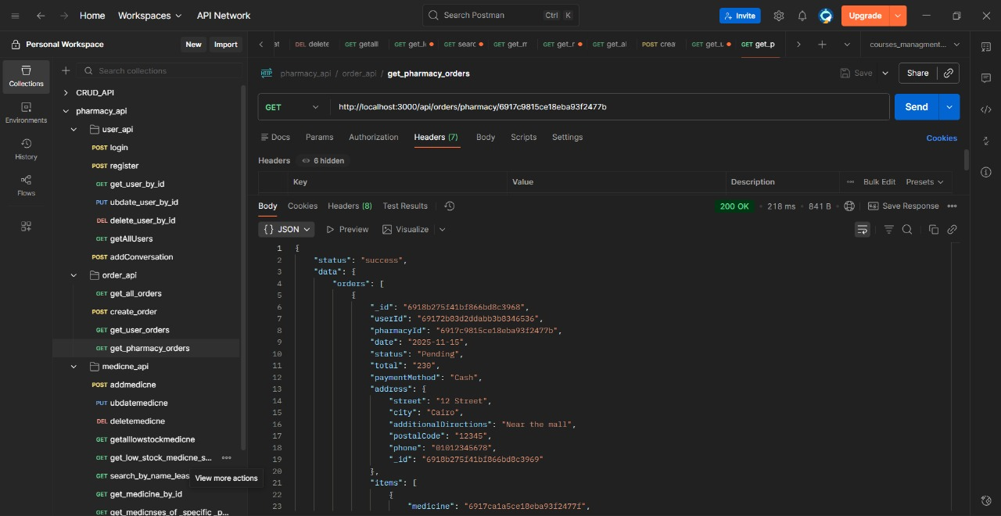

* + - **Get Pharmacy Orders**

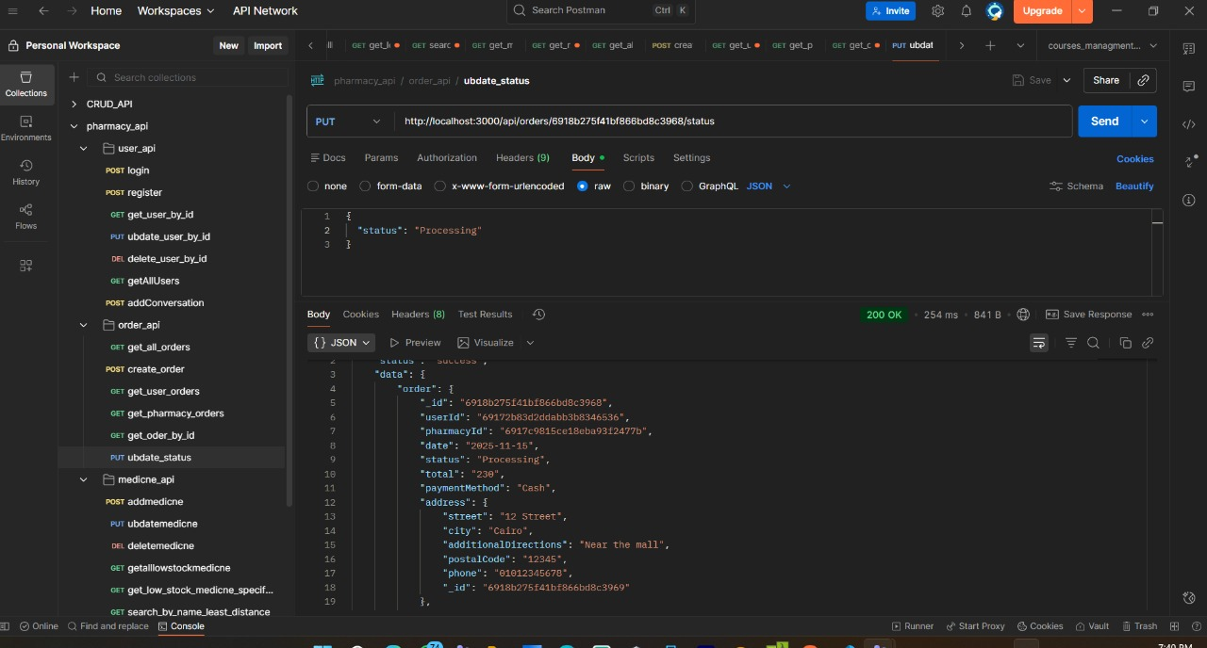

* + - **update status of order**

# **Testing Phase**

To ensure that the user can successfully log in and receive a token. This is a critical test for the authentication system.

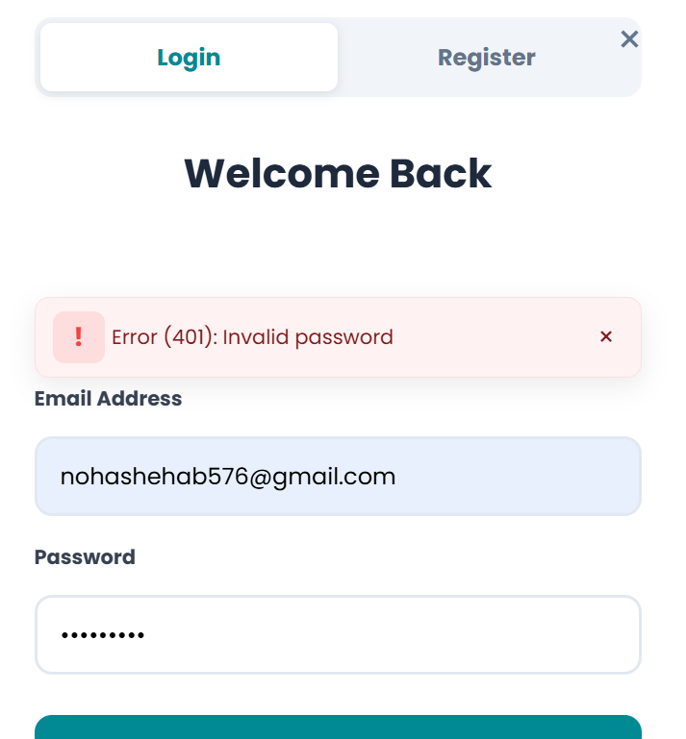 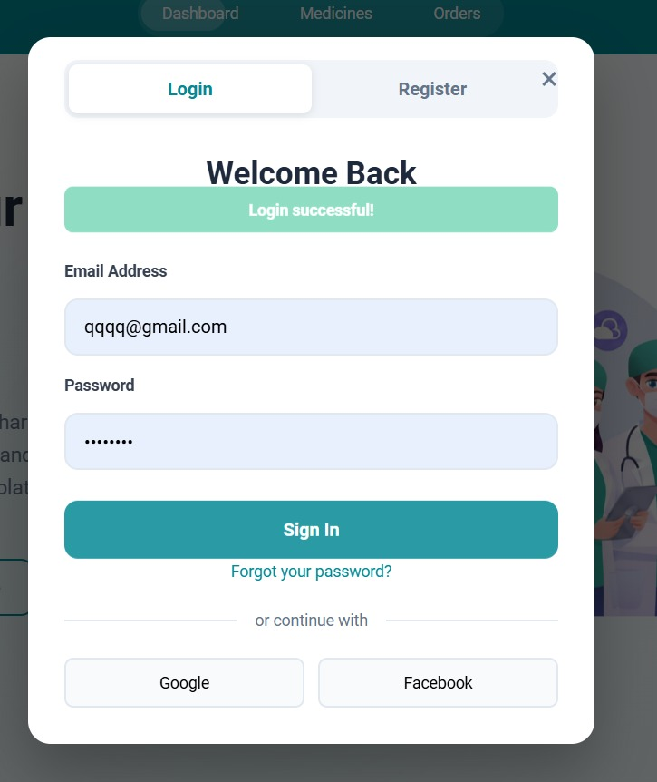

Avatar Upload

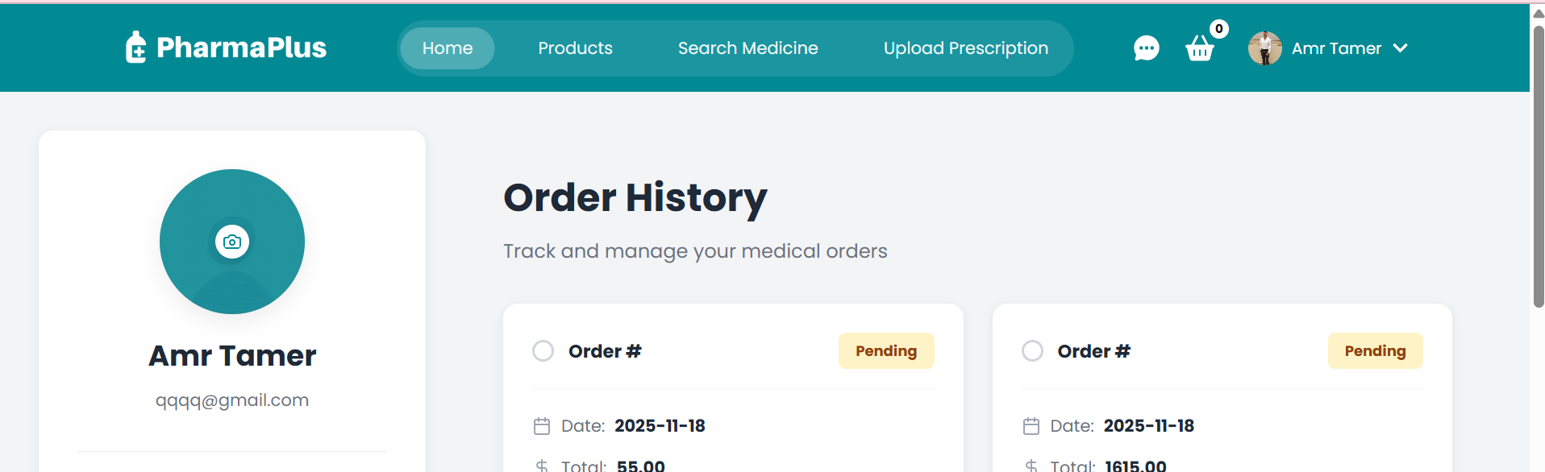

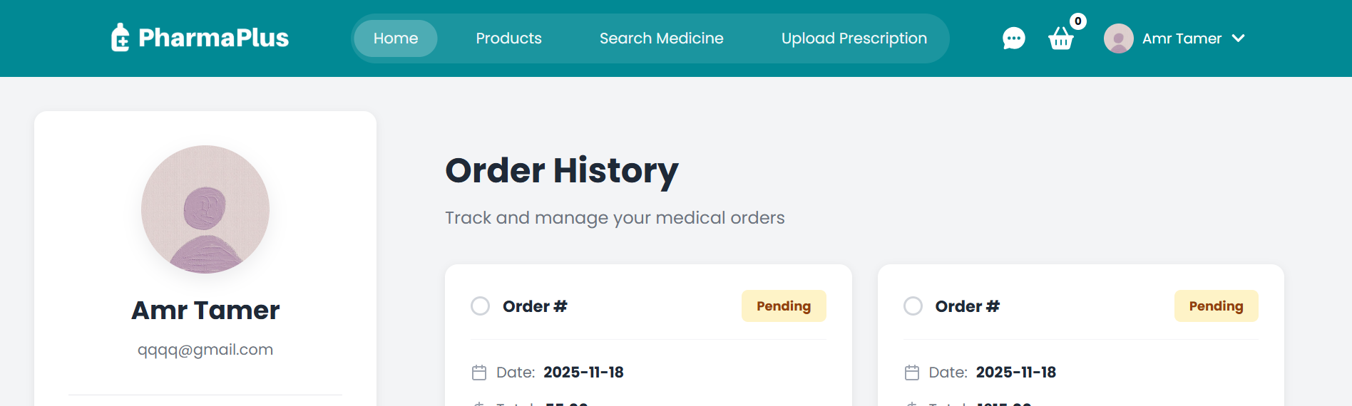

Search Medicine

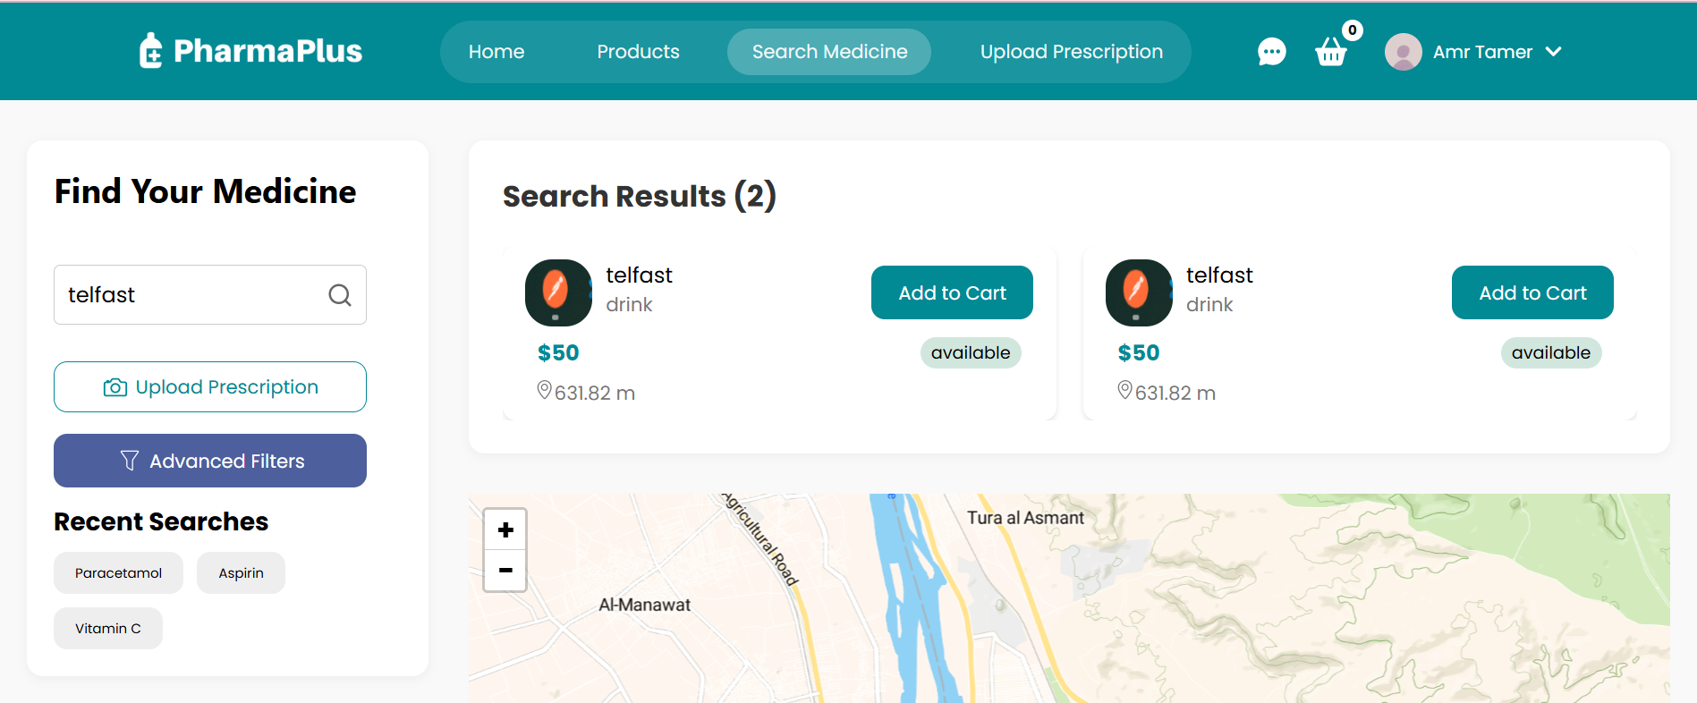

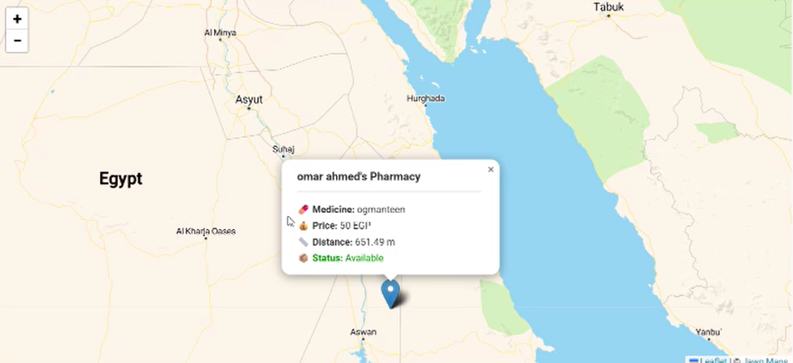

Add to Cart

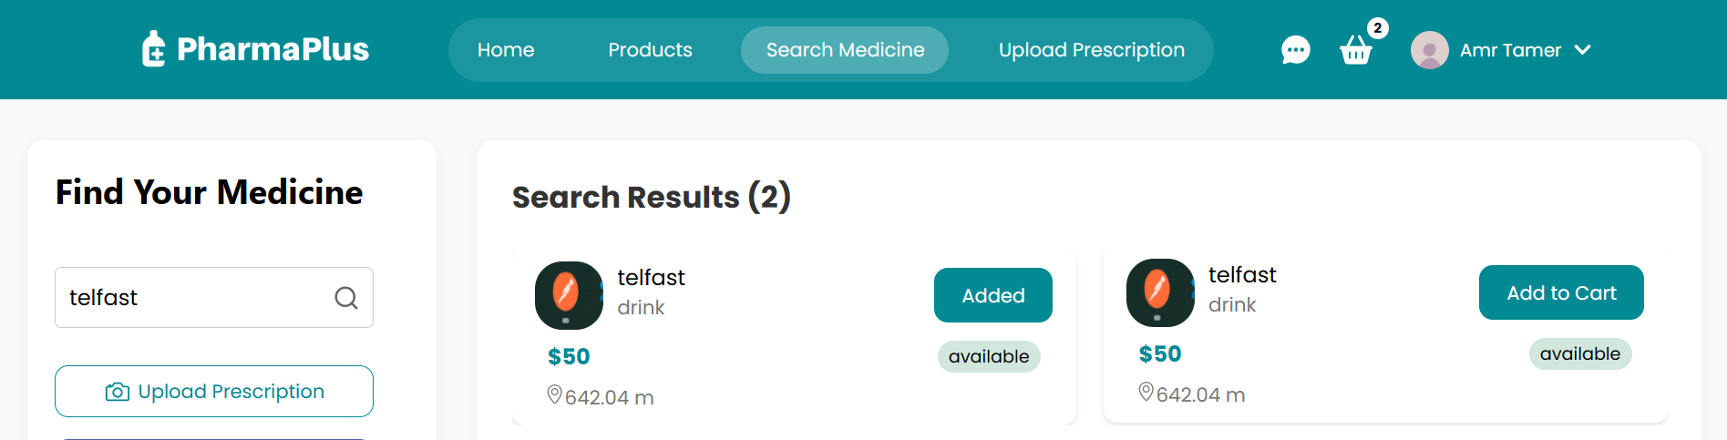

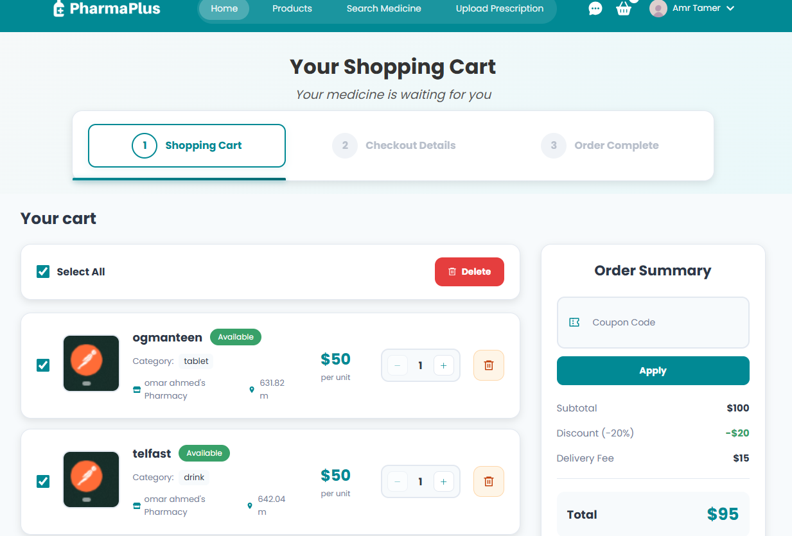

Pharmacy/Admin Orders

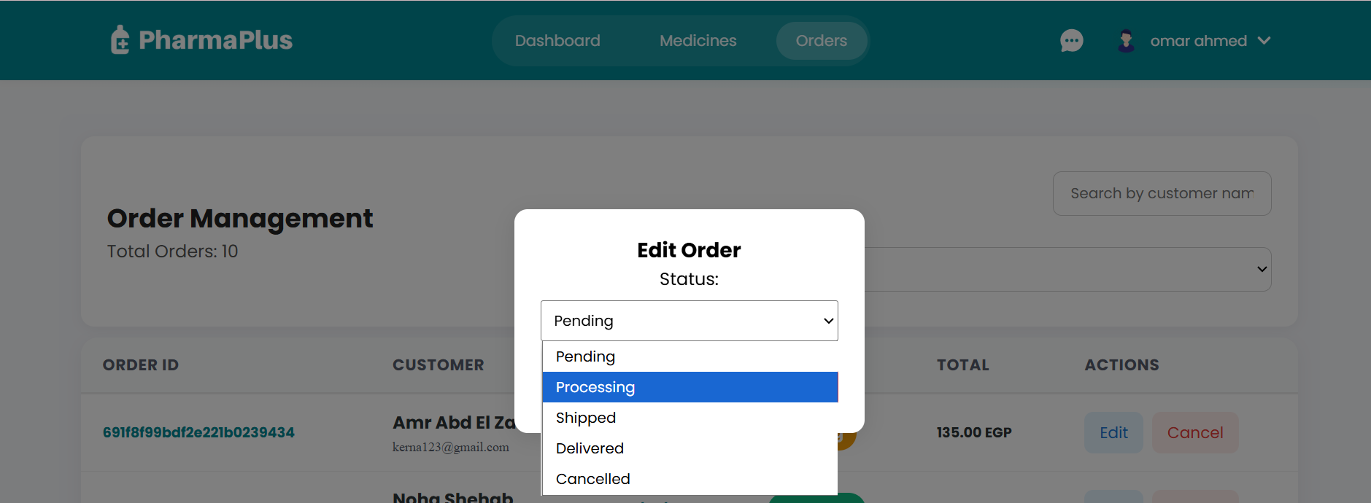

Admin: Create/Edit/Delete Medicine

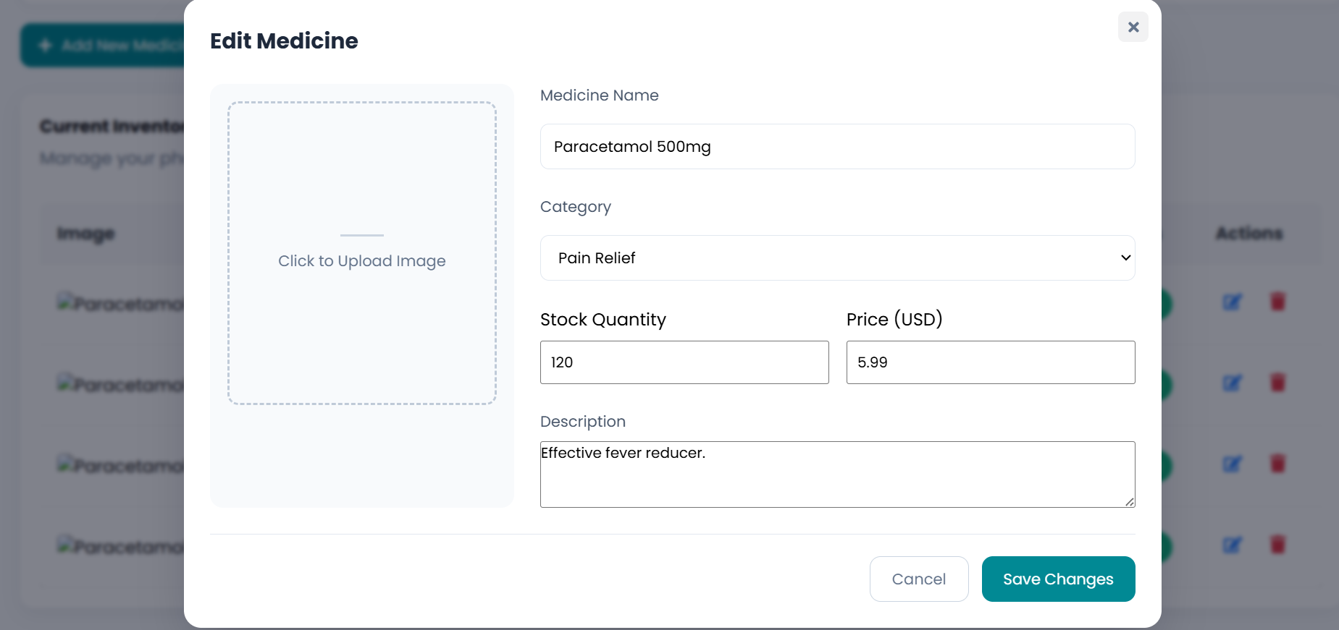

Pharmacy/Super Pharmacies

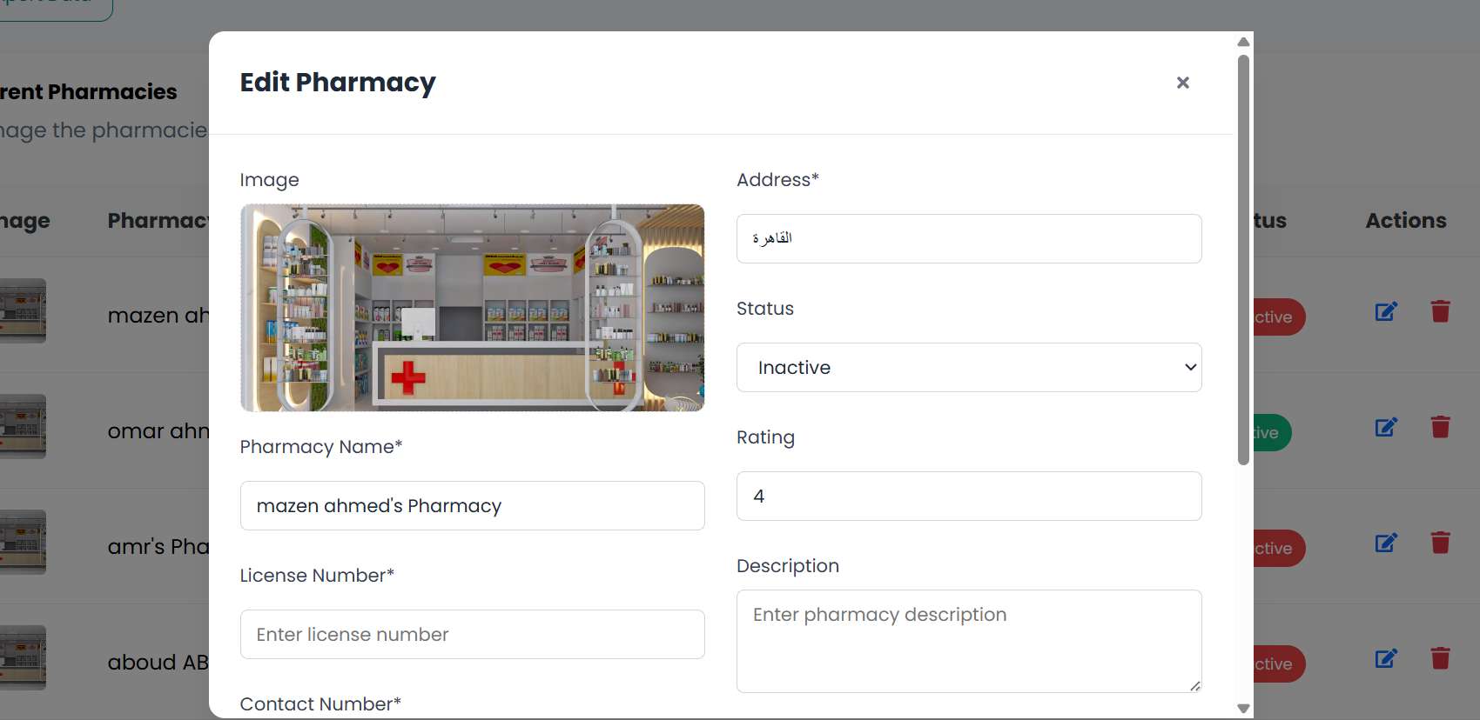

API Error Handling

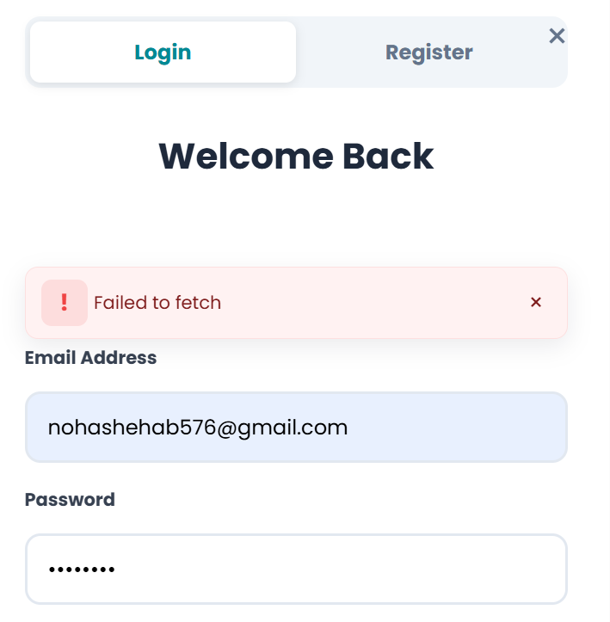

Responsive UI

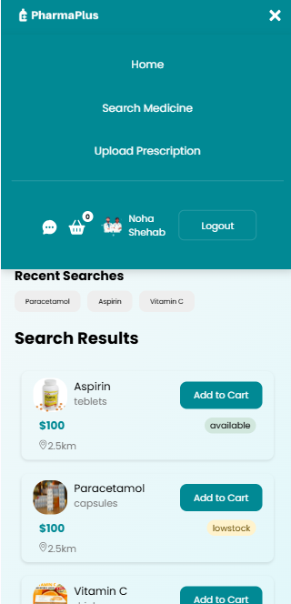

# **Student Wok**

## Mazen Ahmed

**1. SUPER ADMIN GLOBAL ANALYTICS**

**Purpose**:

1. Display platform-wide statistics and analytics dashboard

2. Monitor pharmacy performance and revenue

3. Track user growth and order metrics

**Key Components:**

1. Performance Cards - KPI display

2. User Growth Chart (LineChart)

3. Revenue Distribution (PieChart)

4. Top Pharmacies (BarChart)

5. Pharmacy Performance Table

6. Search & Filter functionality

7. Export Reports

**Data Displayed:**

1. Total users with growth percentage

2. Total revenue (K format)

3. Active pharmacies count

4. Average order value

5. User growth trends

6. Revenue by categories

7. Pharmacy details and sales

**2. SEARCH MEDICINE**

**Purpose:**

1. Search medicines by name and category

2. Find nearby pharmacies

3. Compare prices across pharmacies

**Key Components:**

1. Search Bar with autocomplete

2. Location Filter

3. Price Range Filter

4. Search Results Grid

5. Medicine Card

6. Pharmacy Location Map

7. Sorting Options

8. Pagination

**3. PRESCRIPTION UPLOAD (Frontend Only - In Progress)**

Status: Frontend UI Created - Backend Integration Pending

Note: UI components created but will be modified for full backend integration

**Purpose**:

1. Upload medical prescriptions

2. Store securely for orders

3. Pharmacist review system

4. Maintain prescription history

**Current Frontend Components:**

1. Drag & Drop Area

2. File Preview

3. Prescription Form

4. Medicine List

5. Pharmacy Selection

6. Order Summary

7. File Validator

**Planned Features:**

1. Multiple file upload

2. Drag and drop

3. Image preview

4. Manual medicine entry

5. Pharmacist review request

6. Prescription history

7. Download/print option

**Technologies (To Be Integrated):**

1. File Upload API

2. FormData API

3. Image/PDF validation

4. Backend prescription storage

5. Pharmacist approval workflow

Access: Registered Users Only

Next Steps:

1. Backend API endpoint for prescription upload

2. Database scheme for prescription storage

3. Pharmacist approval system

4. File security and encryption

5. Integration with order management

**4. CHAT SYSTEM (Frontend Only - In Progress)**

Status: Frontend UI Created - Backend Integration Pending

Note: UI components created but will be modified for full backend integration

**Purpose:**

1. Real-time communication between users and pharmacies

2. Customer support and inquiries

3. Medical consultations

4. Order issue resolution

**Current Frontend Components:**

1. Chat List Sidebar

2. Chat Window

3. Message Input Field

4. Message Bubbles

5. User Avatar

6. Typing Indicator

7. Timestamp

**Planned Chat Features:**

1. Real-time messages

2. Message history

3. Typing indicators

4. Online/offline status

5. Send images/files

6. Emoji support

7. Search chat history

8. Archive conversations

**UI Features:**

1. Responsive interface

2. Mobile-friendly

3. Unread count badge

4. Delivery status icons

5. Settings menu

Technologies (To Be Integrated):

1. WebSocket/Socket.io - Real-time messaging

2. Message History Database

3. Read Receipts

4. Notification System

5. File Upload support

Access: All Registered Users

**Next Steps:**

1. Backend Socket.io server setup

2. Message database schema

3. Real-time event handlers

4. User authentication for chat

5. Notification system integration

6. File upload handler

7. Message persistence  
  
**4. Backend System — Fully Developed:  
The backend of the Pharmacy Management System has been fully developed, covering:**

* **RESTful API design for all system modules**
* **Authentication & authorization (JWT/session)**
* **Database modeling and CRUD operations**
* **Error handling and validation**
* **Integration logic between system components**

**This backend implementation is now complete and ready for integration with the frontend.**

**QUICK SUMMARY**

|  |  |  |  |
| --- | --- | --- | --- |
| **Feature** | **Status** | **Access Level** | **Priority** |
| Admin Analytics | Ready | Super Admin Only | Critical |
| Search Medicine | In Dev | All Users | High |
| Prescription Upload | Frontend Only | Registered Users | High |
| Chat System | Frontend Only | Registered Users | Medium |

**IMPORTANT NOTES**

1. All features require valid JWT token

2. Token stored securely in localStorage

3. Auto logout on token expiration

4. Input validation on all forms

5. Error handling with user messages

6. Data encrypted and secure

7. HTTPS communication

8. Responsive design (mobile-first)

9. Lazy loading for performance

10. Accessibility compliant

## Noha Shehab

**1. Frontend Routing System**

**Purpose**

Manage navigation across the platform and protect pages based on user roles (User / Admin / SuperAdmin).

**Tools & Technologies Used**

* React Router DOM
* Context API (AuthContext)
* JWT Decoding
* ProtectedRoute components

**My Implemented Tasks**

* Built the full routing structure (public + protected routes)
* Implemented role-based redirection (User → User Dashboard, Admin → Admin Panel)
* Connected routing with backend authentication
* Added auto-redirect on login/logout
* Synced route protection with JWT token from localStorage

**2. Shopping Cart System**

**Purpose**

Allow users to add, remove, and update medicines before checkout.

**Tools & Technologies Used**

* React Context API (ProductContext & CartContext)
* Fetch API (integration with backend)
* React State Management

**My Implemented Tasks**

* Built the full Cart page UI
* Added add/remove/update quantity functionality
* Synced all cart actions with backend stock
* Connected Cart with ProductContext
* Styled mini-navbar cart icon behavior

**3. Products Page (Active Pharmacies & Medicines)**

**Purpose**

Display all active pharmacies and dynamically load their medicines.

**Tools & Libraries Used**

* Fetch API
* React Hooks
* Custom Carousel UI
* Condition-based rendering

**My Implemented Tasks**

* Fetched all active pharmacies + linked medicines from backend
* Designed horizontal scrolling carousel
* Added “Available / Out of Stock” indicators
* Linked Add to Cart buttons with Cart Context
* Synced dynamic stock numbers with backend

**4. Pharmacy Management (Admin & Super Admin)**

**Purpose**

Enable admins to manage medicines and pharmacies through dashboards.

**Tools Used**

* CRUD APIs
* Context API
* React Components

**My Implemented Tasks**

* Built medicine management pages (create/edit/delete)
* Built pharmacy management interface for Super Admin
* Integrated backend APIs for update/delete actions
* Ensured real-time UI updates with Context state

**5. Authentication Integration**

**Purpose**

Secure login, registration, session management, and access control.

**Tools Used**

* JWT Token
* LocalStorage
* API Fetch
* Form Validation

**My Implemented Tasks**

* Implemented API fetching for login & registration
* Displayed backend validation errors in the UI
* Decoded JWT token & saved it securely in localStorage
* Synced authentication with navbar & routing
* Handled session persistence on refresh

**6. Navigation & UI Components**

**Purpose**

Provide a smooth and responsive user experience.

**Tools Used**

* Framer Motion
* CSS Modules
* Responsive Layouts (Flex/Grid)

**My Implemented Tasks**

* Built main navbar + mini-navbar
* Added animations & transitions using Framer Motion
* Created responsive UI for all screen sizes
* Updated navigation dynamically based on login state

## Amr Tamer

**1. PROFILE PAGE**

**Purpose**:

1. Let users view and edit personal details (name, email, phone, address).
2. Allow secure password changes with strength validation.
3. Upload, preview and crop avatar images.
4. Show past orders with filters and allow checking order status and history.
5. Surface last-login/activity and linked pharmacies (if applicable).

**Tools used**:

* React Hooks (useState, useEffect)
* Context API (UseAuth)
* Fetch / Axios for API calls to /api/users
* Client-side validation (Yup or custom)
* Recharts (if showing order-related charts) / simple tables

**Key Components:**

1. Profile Form - editable fields (name, email, phone, address)
2. Change Password Form
3. Avatar Upload & Preview component
4. Save/Cancel controls
5. Field-level validation and toasts

**My Implemented Tasks:**

* Built profile form with controlled inputs and client-side validation.
* Implemented avatar upload + preview and client-side resizing.
* Added change-password form with strength meter and secure submit.
* Added Past Orders list with filters (date, status) and per-order detail modal showing items, totals, timestamps and status history.
* Hooked profile updates to re-sync auth context and show loading/success/error states.

**2. ADMIN DASHBOARD PAGE**

**Purpose:**

1. Display pharmacy-level KPIs (total revenue, total orders, stock value, active customers).
2. Present interactive charts for monthly sales and revenue-by-category.
3. Surface recent orders and low-stock alerts for operational action.
4. Provide sorting/filtering and CSV/Excel export for reports.
5. Offer responsive layout for tablet/phone use.

**Tools Used**

* React Hooks (useState, useEffect)
* Rendered interactive Monthly Sales chart and Revenue-by-Category visualizations.
* Recharts (LineChart, BarChart, PieChart)
* API Fetch
* Context API - Authentication (useAuth)

**Key Components:**

1. Stat Cards - KPI display (Total Revenue, Orders, Stock Value, Active Customers)
2. Monthly Sales Chart (LineChart)
3. Revenue By Category (Bar/Pie Chart)
4. Recent Orders Table
5. Low Stock Alerts list
6. Export Reports button

**My Implemented Tasks**

* Integrated [getCustomerAnalytics](vscode-file://vscode-app/c:/Users/amrot/AppData/Local/Programs/Microsoft%20VS%20Code/resources/app/out/vs/code/electron-browser/workbench/workbench.html" \o ") and mapped [platformSummary](vscode-file://vscode-app/c:/Users/amrot/AppData/Local/Programs/Microsoft%20VS%20Code/resources/app/out/vs/code/electron-browser/workbench/workbench.html" \o ") to stat cards.
* Implemented full-page loading overlay that responds to parent + child loading states.
* Rendered interactive Monthly Sales chart and Revenue-by-Category visualizations.
* Built Recent Orders table with sorting, filtering, and export (CSV) support.
* Added Low Stock alerts component and responsive grid layout.

**3. ADMIN DASHBOARD PAGE**

**Purpose:**

1. Present platform-wide metrics (total users, total revenue, active pharmacies).
2. Show user-growth and retention trends (line charts) and sliding last‑N‑day sales trends.
3. Visualize revenue distribution and top-performing pharmacies (pie/bar charts).
4. Enable drilldowns and exportable reports for analysis.
5. Provide monitoring and auditing tools for multi-tenant oversight.

**Tools Used:**

* React Hooks (useState, useEffect)
* Recharts (LineChart, BarChart, PieChart)
* Context API ([useAuth](vscode-file://vscode-app/c:/Users/amrot/AppData/Local/Programs/Microsoft%20VS%20Code/resources/app/out/vs/code/electron-browser/workbench/workbench.html" \o "))
* API integration

**Key Components:**

1. Performance Cards - KPI display
2. User Growth Chart (LineChart)
3. Revenue Distribution (PieChart)
4. Top Pharmacies (BarChart)
5. Pharmacy Performance Table
6. Search & Filter functionality
7. Export Reports

**My Implemented Tasks:**

* Wired [getSuperDashboard](vscode-file://vscode-app/c:/Users/amrot/AppData/Local/Programs/Microsoft%20VS%20Code/resources/app/out/vs/code/electron-browser/workbench/workbench.html" \o ") to fetch platform-level payload and populated metric cards.
* Added admin-style full-page loader and hid main content during loading.
* Passed normalized [dailySalesThisMonth](vscode-file://vscode-app/c:/Users/amrot/AppData/Local/Programs/Microsoft%20VS%20Code/resources/app/out/vs/code/electron-browser/workbench/workbench.html" \o ") series to [SalesTrendChart](vscode-file://vscode-app/c:/Users/amrot/AppData/Local/Programs/Microsoft%20VS%20Code/resources/app/out/vs/code/electron-browser/workbench/workbench.html" \o ") and ensured time-series zero-fill/ISO normalization for stable charts.
* Added StockMovement and OrderStatus charts and top-pharmacies table; ensured components accept parent data slices.
* Fixed module export issues (single default export) and guarded against duplicate fetches in StrictMode.

## Mariam Mohamed

1-HOME PAGE:

**Purpose**

**- The homepage is the primary entry point of the PharmaPlus web application. It aggregates product discovery (search and listings), promotional content (offers and featured slider), partner visibility, and quick access to the shopping flow (cart preview and order summary). It is designed to be responsive, accessible, and to provide a fast, low-friction path from discovery to checkout.**

**Tools Used**

**• React (component-driven UI)**

**• Vite (development and build tooling)**

**• CSS Modules (scoped styles per component)**

**• Context API (ProductContext, SearchMedicineContext, OrderContext)**

**• Custom hooks (useSearchMedicine, useAuth, useScrollReveal, useDisableBodyScroll)**

**• Local assets (images under src/pages/homepage/images / assets)**

**My Implemented Tasks**

**- Page composition and routing:**

**- Implemented Homepage.jsx which composes the homepage by mounting Hero, Products, Offers, About, Partners, CursorEffect, and Footer and exposes section anchors (#products, #offers, #about, #partners).**

**- Hero section:**

**- Built Hero.jsx with headline, description, CTAs and an interactive hero image (mouse-parallax transform). Responsive breakpoints and animated float effect are implemented in Hero.module.css.**

**- Products listing:**

**- Implemented Products.jsx that renders a featured product grid/slider using a local sample dataset. Styling, hover states, and responsive grid behavior live in Products.module.css. The component is ready to be connected to ProductContext or a backend API.**

**- Offers & promotions:**

**- Implemented Offers.jsx to display promotional cards and a marquee promo strip. Uses Offers.module.css and useScrollReveal to animate cards into view.**

**- About section:**

**- Implemented About.jsx as a static informational block with image and feature items, using About.module.css and scroll reveal animations.**

**- Partners block:**

**- Implemented Partners.jsx to display partner logos in a responsive grid with hover effects, styled in Partners.module.css.**

**- Footer & global header affordances:**

**- Implemented Footer.jsx (branding, quick links, services, support links) and relied on the global Navbar components for navigation and cart entry points.**

**.**

**- Auth modal:**

**- Implemented LoginModal.jsx to handle login and registration flows (forms, validation, API error parsing, loading states). The modal disables background scroll while open via useDisableBodyScroll.**

**- Visual polish and effects:**

**- Added CursorEffect.jsx for a subtle cursor pill and animated background. Implemented reveal-on-scroll behavior via useScrollReveal and per-component CSS animations.**

**- Accessibility and performance considerations:**

**- Applied responsive breakpoints and CSS module scoping. Suggested ARIA attributes and keyboard focus handling for interactive flows (search, add-to-cart, modal). Images are prepared to be lazy-loaded and heavy UI can be code-split.**

**- Hooks & utilities added to homepage folder:**

**- hooks/useScrollReveal.js — scroll reveal animation helper.**

**- hooks/useDisableBodyScroll.js — prevents background scrolling when modals are open.**

**2- Order Management page:**Purpose

- The Order Management page provides pharmacy staff and admins a single interface to monitor, search, filter, update, and cancel customer orders. It is intended for operational workflows: review recent orders, inspect customer details, update order status (Processing → Shipped → Delivered), and remove/cancel orders when required.

Tools Used

• React (JSX) — component-based UI

• Vite — development toolchain

• CSS Modules — per-component styling (*.module.css files)

• Fetch / browser networking — client requests to backend order and user endpoints

• Context API (AuthContext) — access token and auth state for protected API calls

• Local hooks / state (useEffect, useState) — data fetching, loading state, pagination

My Implemented Tasks

- Page composition & data loading:

- Implemented OrderManagement.jsx as the page entry. It fetches paginated orders for a configured pharmacyId using the AuthContext token, enriches each order with user information (if available), and manages loading and pagination state.

- Orders table & filtering:

- Implemented OrdersTable/OrdersTable.jsx to render a searchable and filterable table of orders with columns: Order ID, Customer, Date, Status, Total, Actions.

- Added client-side search (by customer name or order ID) and status filtering to help operators quickly find orders.

- Status-to-class mapping provides visual status cues (Pending, Processing, Shipped, Delivered, Cancelled).

- Header & controls:

- Implemented OrdersHeader/OrdersHeader.jsx to show page title, total orders, a search input, and a status filter select.

- Edit status modal:

- Implemented EditModal/EditModal.jsx to update an order's status. The modal pre-fills the current status and calls the PUT status endpoint on save; the parent page updates the orders list optimistically after a successful response.

- Cancel/Delete modal:

- Implemented CancelModal/CancelModal.jsx to confirm destructive actions. On confirm the page calls DELETE on the order endpoint and removes the order from the list on success.

- Pagination and UI states:

- Implemented simple client pagination controls (Next / Previous) and a loading spinner state while fetching.

- OrderManagement.jsx exposes page state and guards navigation by totalPages.

- Error handling and resilience:

- Basic network error handling: logs errors and clears list on failure. User-facing improvements (toasts, retries) are suggested for future work.

Relevant files

- src/pages/OrderManagement/OrderManagement.jsx — main page composition and data-fetching logic.

- src/pages/OrderManagement/OrderManagement.module.css — page styles.

- src/pages/OrderManagement/components/OrdersTable/OrdersTable.jsx — table UI, search, filtering, and action buttons.

- src/pages/OrderManagement/components/OrdersTable/OrdersTable.module.css — table styles.

- src/pages/OrderManagement/components/OrdersHeader/OrdersHeader.jsx — header, search input, and filter UI.

- src/pages/OrderManagement/components/OrdersHeader/OrdersHeader.module.css — header styles.

- src/pages/OrderManagement/components/EditModal/EditModal.jsx — modal to change order status.

- src/pages/OrderManagement/components/EditModal/EditModal.module.css — edit modal styles.

- src/pages/OrderManagement/components/CancelModal/CancelModal.jsx — modal to confirm order cancellation/deletion.

- src/pages/OrderManagement/components/CancelModal/CancelModal.module.css — cancel modal styles.

**3-Reportsoverview PAGE:**Purpose - Holds the Reports Overview page and its supporting components, mock data and styles. This area provides UI for filtering, viewing, exporting, and summarizing report data for admins and super-admins.

Tools Used • React (JSX), CSS Modules, plain JavaScript modules for mock data, and existing app contexts/hooks.

My Implemented Tasks - Composed the page layout, connected UI components to reportsData, and added scoped styles for layout and responsiveness.

Files and components (each entry follows: Purpose - . Tools Used • My Implemented Tasks - )

- data.js

- Purpose - Provides mock report records (reportsData) used by the page and table components (fields: id, name, pharmacy, date, status, generatedBy, type).

- Tools Used • Plain JavaScript module / named export.

- My Implemented Tasks - Created and exported a representative dataset of sample reports for UI development and component testing.

- reportsoverview.jsx

- Purpose - Main page component that composes the reports overview: loads reportsData, renders summary cards, filter controls, the reports table, and export/alert flows.

- Tools Used • React functional component, hooks (useState, useEffect), component imports from ./components, CSS module import (reportsoverview.module.css).

- My Implemented Tasks - Built the page structure and state handling, wired filter and table interactions to the sample data, integrated export flow and alert components, and applied module styles for layout.

- reportsoverview.module.css

- Purpose - Encapsulated styles for the reportsoverview page — spacing, responsive grid for summary cards, layout for top controls and table area.

- Tools Used • CSS Modules (scoped CSS).

- My Implemented Tasks - Implemented responsive layout rules and classes used by the page and its child components to ensure consistent spacing and mobile-friendly behaviour.

- components/ExportAlert/

- Purpose - Component that displays export confirmation and success/failure notifications for report export actions (CSV/Excel).

- Tools Used • React, component-level CSS Modules, simple file-download helpers.

- My Implemented Tasks - Implemented the UI for export confirmation and success/failure alert states; connected to the page export trigger for user feedback.

- components/ReportRow/

- Purpose - Renders a single report row for the ReportsTable — formats cells (name, pharmacy, date, status, generatedBy) and renders row actions.

- Tools Used • React, CSS Modules, small helpers for formatting and status badges.

- My Implemented Tasks - Implemented row markup, status badge display, and action handlers used by the table (view/download/etc.).

- components/ReportsFilter/

- Purpose - Presents filtering controls (search, date range, type, status, pharmacy) and exposes filter values to the parent page.

- Tools Used • React controlled inputs, lightweight debounce/search helpers.

- My Implemented Tasks - Built filter controls, handled user input/state, and exposed a clean callback API consumed by reportsoverview.jsx to narrow reportsData.

- components/ReportsTable/

- Purpose - Composes the reports table — renders header, rows (using ReportRow), supports sorting, pagination, and bulk actions.

- Tools Used • React, CSS Modules, simple client-side pagination and sorting logic.

- My Implemented Tasks - Implemented table layout, connected it to the filtered dataset, added client-side sorting and paging, and integrated row-level actions.

- components/SummaryCards/

- Purpose - Displays KPI summary cards (e.g., total reports, completed, failed, counts by type) for at-a-glance metrics.

- Tools Used • React, CSS Modules, JS aggregation logic.

- My Implemented Tasks - Created summary card components and aggregation logic to compute counts/percentages from reportsData, and wired them to update when filters change.

# 5-Authentication Modal (Login & Register Interfaces)

# Overview:

Authentication Modal (Login & Register Interfaces)

Overview

The authentication system is implemented as a modern, responsive modal that overlays the current page. It provides two separate flows — Login and Register — both accessible through a toggle at the top of the modal. The design is clean, minimal, and aligned with the PharmaPlus branding.

Login Interface

Purpose

Allow existing users to securely sign into their account with minimal friction.

UI & Features (as shown in the screenshot)

Tab Navigation: Toggle between Login and Register at the top of the modal.

Welcome Header: “Welcome Back” title to create a friendly, familiar start.

Input Fields:

Email Address (validated email format)

Password (hidden input)

Primary Action:

Sign In button with full-width styling + loading state during API calls.

Secondary Options:

“Forgot your password?” link for recovery.

Divider: “or continue with”

Social Authentication Buttons:

Google

Facebook

UX Details:

Smooth modal animation

Background dimming (backdrop blur)

Scroll locked using useDisableBodyScroll

Registration Interface

Purpose

Enable new users to create an account with full profile details and account type selection.

UI & Features (as shown in screenshot)

Tab Navigation: “Register” tab becomes highlighted when selected.

Header: Create Account section title.

Account Type Selection:

Dropdown with options such as User (Customer) or future roles.

Input Fields:

First Name

Last Name

Email Address

Mobile Number (supporting both international + local formats)

Password

Confirm Password

Scrollable Modal:

Automatically becomes scrollable for long forms on smaller screens.

Validation Rules:

Required fields

Email format check

Phone number pattern

Password match validation

Submit Action:

“Create Account” button with loading indication during registration.

Behavior & Interaction

The modal remains centered with rounded corners and shadow for depth.

Clicking outside the modal or the "X" icon closes it.

When switching between tabs, the form fields update instantly without remounting the modal.

All user input is handled through controlled React components for real-time validation.

# **Conclusion & Future Work**

## Conclusion

PharmaPlus succeeds in creating a complete and scalable solution for digitizing pharmacy operations. It enhances accessibility for customers, streamlines administrative tasks for pharmacists, and provides comprehensive oversight for super admins. The system demonstrates practical application of modern web technologies, secure access control, RESTful API design, and modular architecture.

The work completed shows strong integration between the **frontend (React, Vite) and backend (Node.js, Express, MongoDB)**, supported by effective state management, dynamic analytics, and interactive visual components. While the platform is fully operational, several advanced features, such as real-time communication and integrated payment systems—remain as opportunities for further development.

## Future Work

**A. Real-Time Communication**

* Implement WebSockets for instant order status updates
* Live chat between customers and pharmacists
* Push notifications via browser or mobile

**B. Payment Processing & Financial Workflow**

* Integrate Stripe / PayPal / mobile wallets
* Automatic invoice generation
* Secure digital payment verification

**C. Advanced Analytics & AI**

* Stock demand forecasting using machine learning
* Personalized product recommendations
* Pharmacy performance heatmaps

**D. Mobile Application Development**

* Native iOS and Android versions
* Offline browsing mode
* Biometric login

**E. Delivery & Tracking System**

* GPS-based real-time delivery tracking
* Delivery partner and route management
* Automated ETA calculations

**F. Enterprise & Global Features**

* Multi-language and multi-currency support
* Regulatory compliance (HIPAA/GDPR)
* Multi-pharmacy marketplace system

**G**. **Enhanced Prescription & Healthcare Services**

* **AI medical assistant** for health questions (Gemini-style)
* Automatic detection of drug interactions & warnings
* Smart reminders for medicine schedules